**ĐẠI HỌC KHOA HỌC TỰ NHIÊN TP.HCM**

**KHOA TOÁN – TIN HỌC**



BÁO CÁO MÔN  
**LẬP TRÌNH PHP**

**Đề tài:**



**Giảng viên hướng dẫn:**

TS. Trần Anh Tuấn

**Sinh viên:**

Tạ Hoàng Thảo Vy – 1511353

Contents

Project setup (for window 10) 3

Requirement: 3

How to setup: 3

Install Xampp: 3

Install composer: 6

Step to step to run project: 8

Database design: 14

Users table: 14

Posts table: 15

Comments table: 16

Likes table: 16

Friends table: 17

Groups table: 17

Messages table: 18

Frontend and work flows: 19

Login/Register: 19

Home page 20

Search user: 20

View profile: 21

Chat and message: 23

Friends: 26

Backend and functions: 29

General explanation: 29

Auth (login + register + logout): 31

Friend and group panel: 31

Post: 35

Comments: 37

Likes: 39

Friends and requests: 39

Chat messages: 41

User profile: 43

# Project setup (for window 10)

## Requirement:

* Composer.
* Laravel framework.
* mySql.
* Xampp.
* PHP.

## How to setup:

### Install Xampp:

* Browse to <https://www.apachefriends.org/download.html>
* Download (recommend PHP version >= 7.0)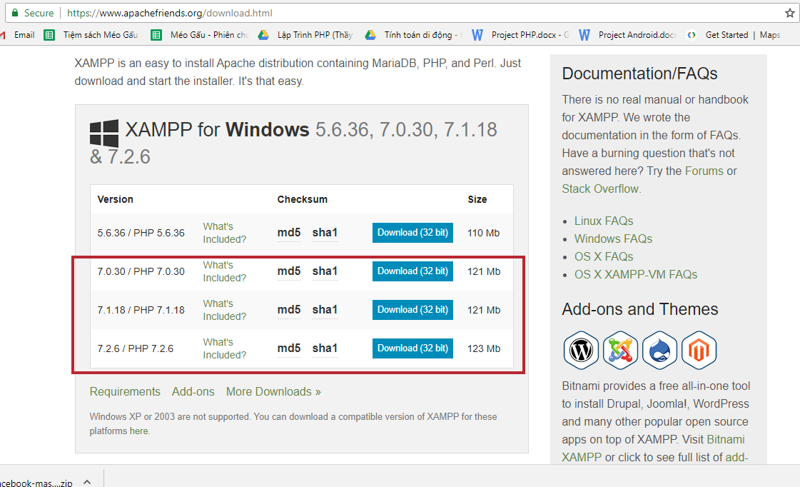
* Go to Environment

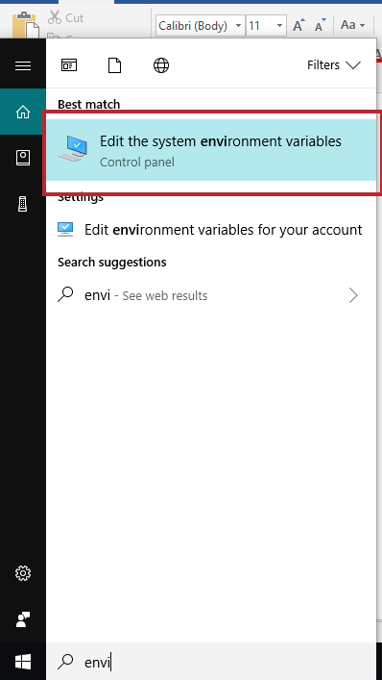

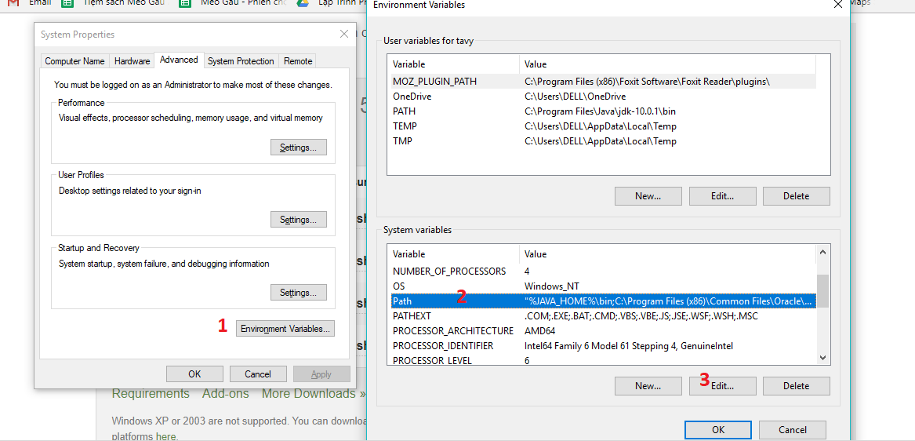

* Add path to your “php” project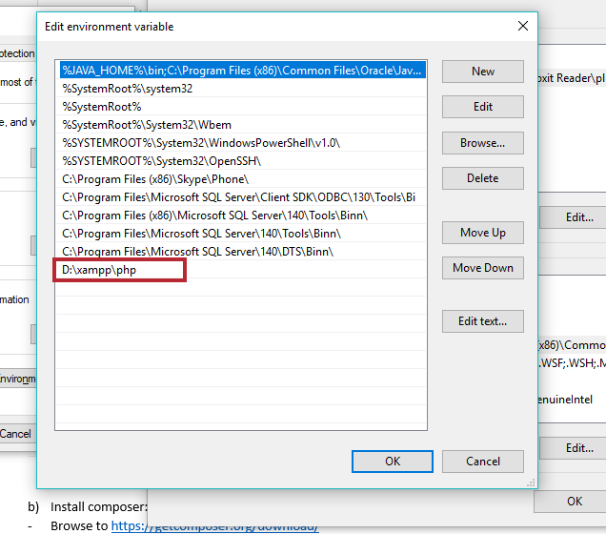
* Expected result: open terminal on window and run: “php -v” 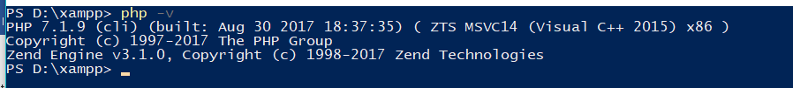

### Install composer:

* Browse to <https://getcomposer.org/download/>
* Click this and download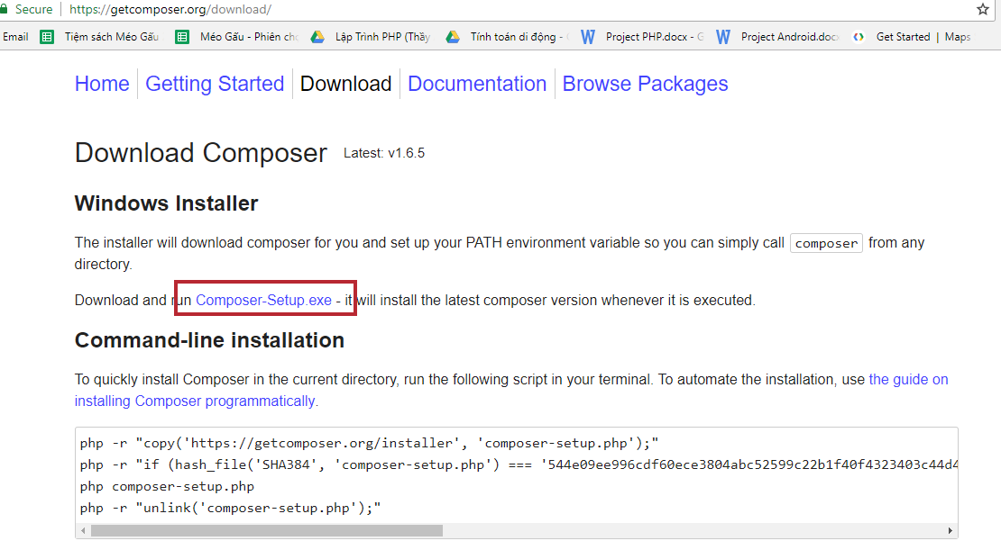
* Run installer, keep default setup, if on step 2, you do not see php path, you can add manually like picture below: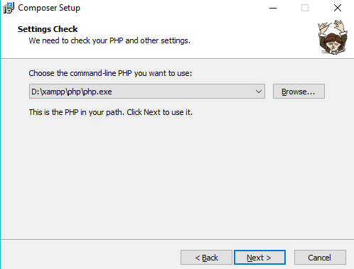
* Expected result: run “composer -v”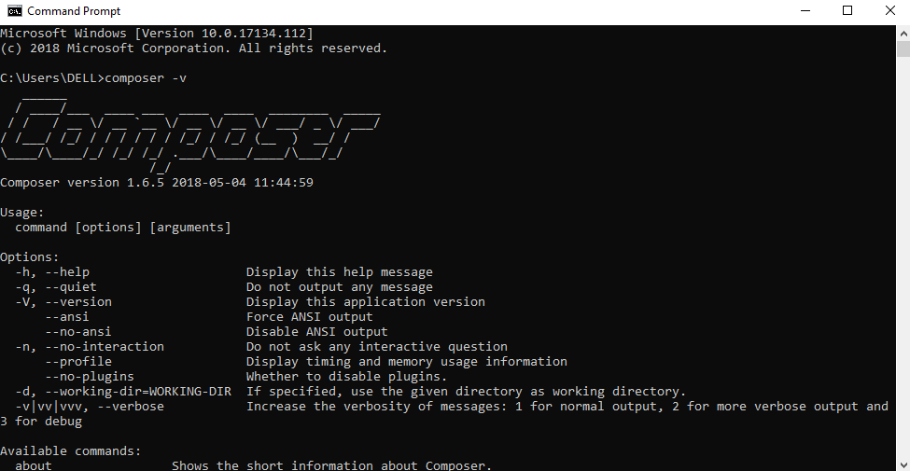

## Step to step to run project:

* Lunch Xampp application, then run start apache and mysql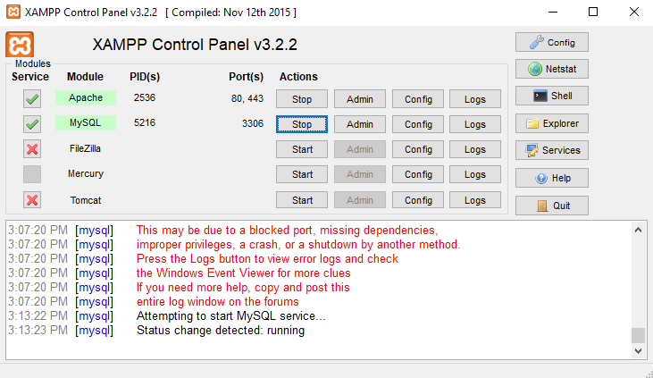
* Go to project root, run these command line:

cd mini-facebook (make sure your path is pointing to folder /mini-facebook)

composer install

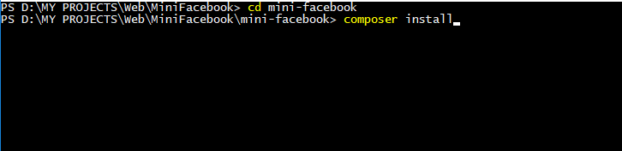

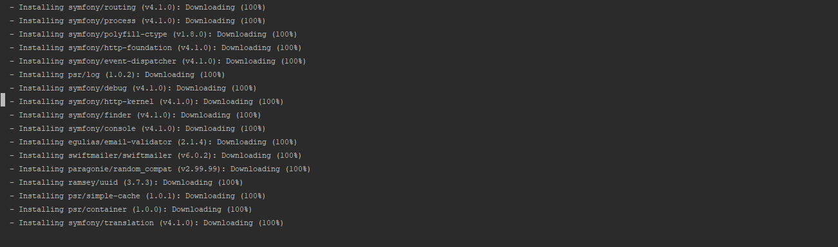

* After install it will have a folder names “vendor” in “/mini-facebook” folder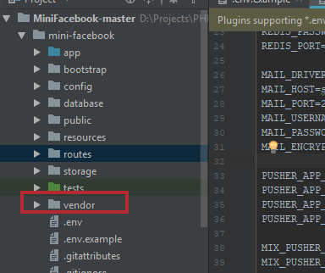
* Open folder “/mini-facebook”, copy file “.env.example” and paste to new file names “.env” (you should use command line to create .env file on window)
* Open xampp, click this: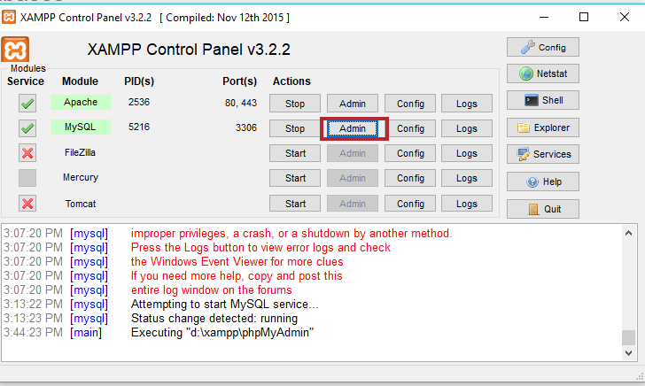
* Then it will browse to mysql admin on browser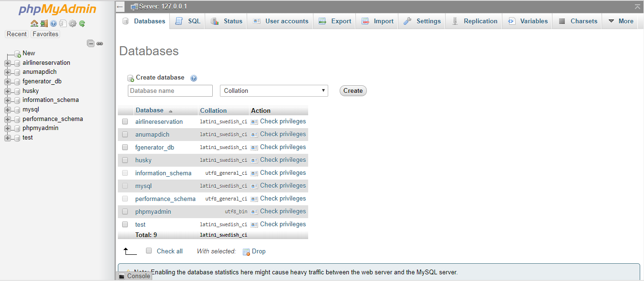
* Add new database name: “minifacebook_db”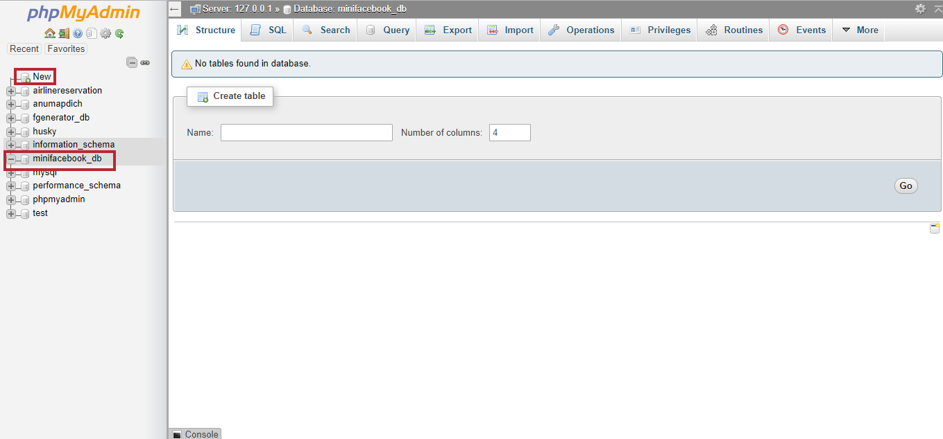
* Change .env file, make sure it fits with database name in mysql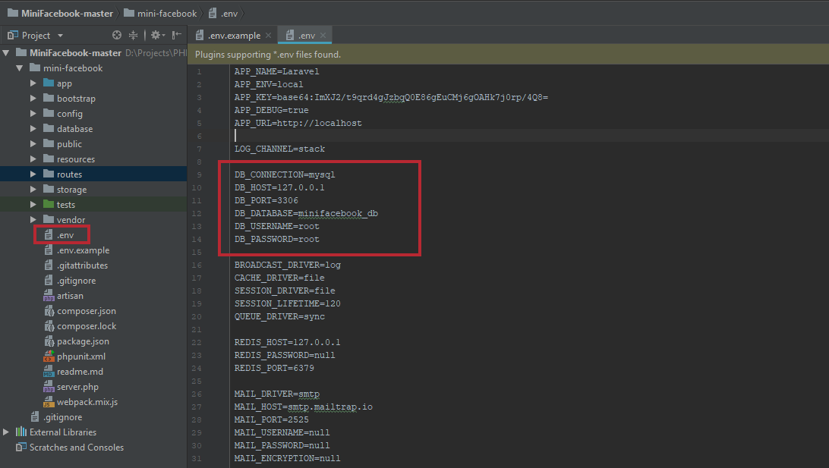
* Then open command line on folder “/mini-facebook” and run: php artisan key:generate
* There will be a key add to APP_KEY in .env file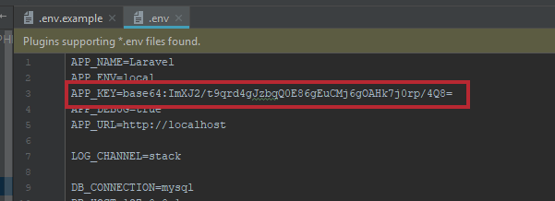
* Then run: php artisan migrate:refresh –seed
* Result: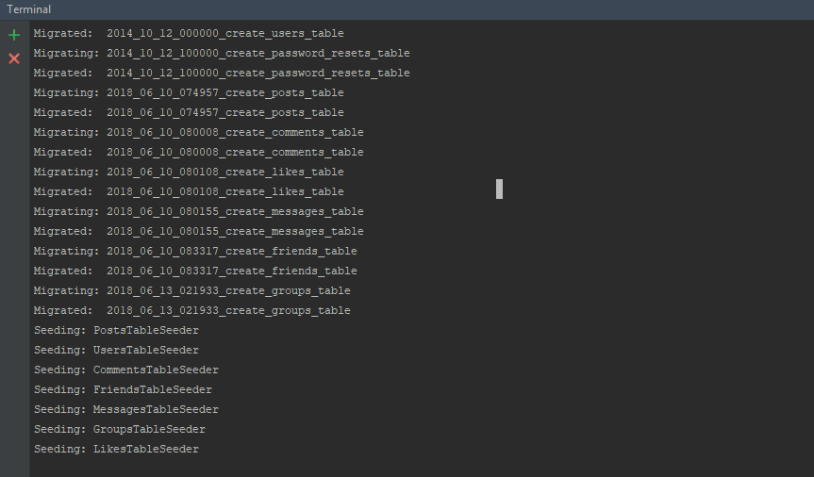
* Go to path “C:\Windows\System32\drivers\etc”, open “hosts” file as notepad, then add new line: 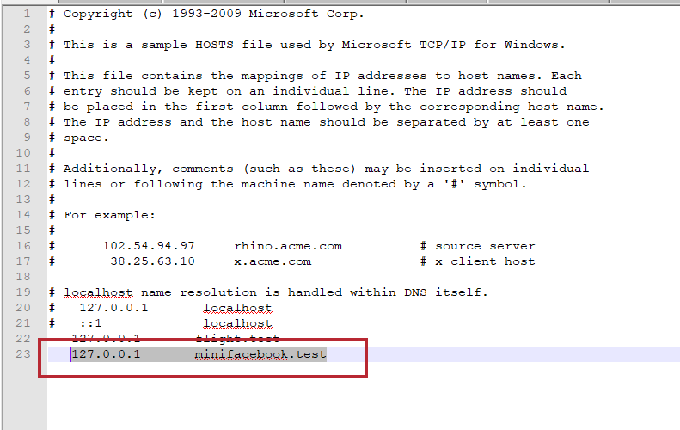
* Go to “\xampp\apache\conf\extra”, then open file “httpd-vhosts.conf” as notepad, then add these lines

<VirtualHost *:80>

DocumentRoot "<absolute path to your project>\MiniFacebook-master\MiniFacebook-master\mini-facebook\public"

ServerName minifacebook.test

</VirtualHost>

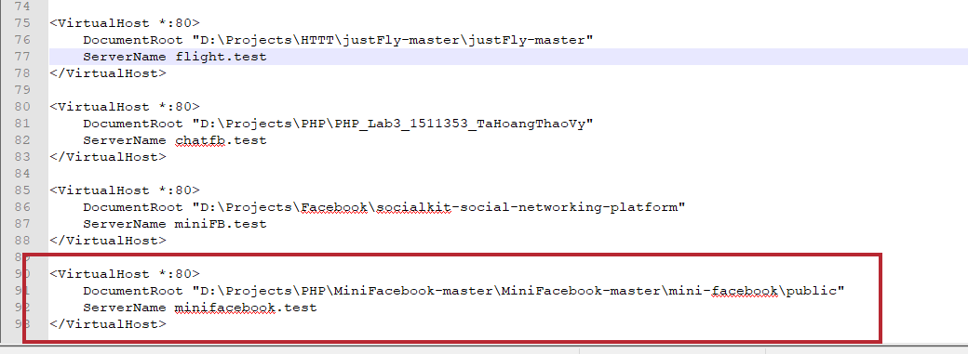

* Restart apache in xampp (THIS IS IMPORTANT!)
* Now browse to “minifacebook.test” and have fun!

# Database design:

* There are totally 7 main tables in database: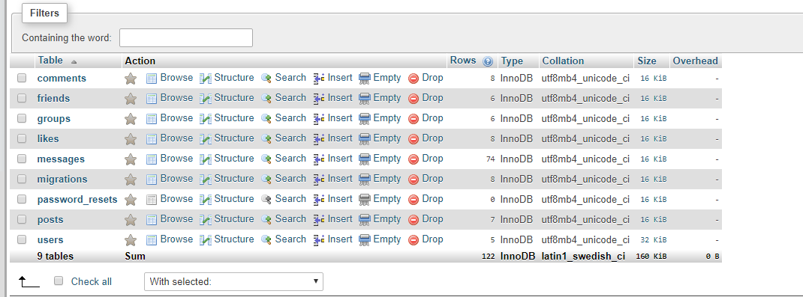

Table “migrations” and “password_resets” are created default by Laravel framework

## Users table:

This table save user data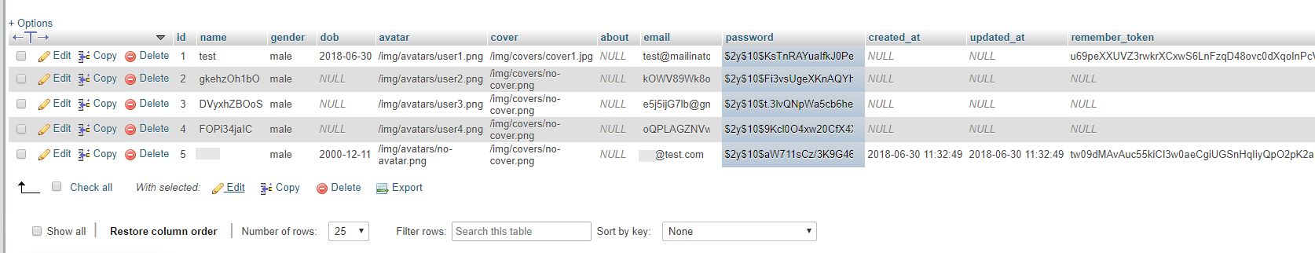

Fields explanation:

* There are some basic fields, such as: “name”, “email”, “password”, “gender” and “dob” (date of birth) for registration form
* Others are for user detail page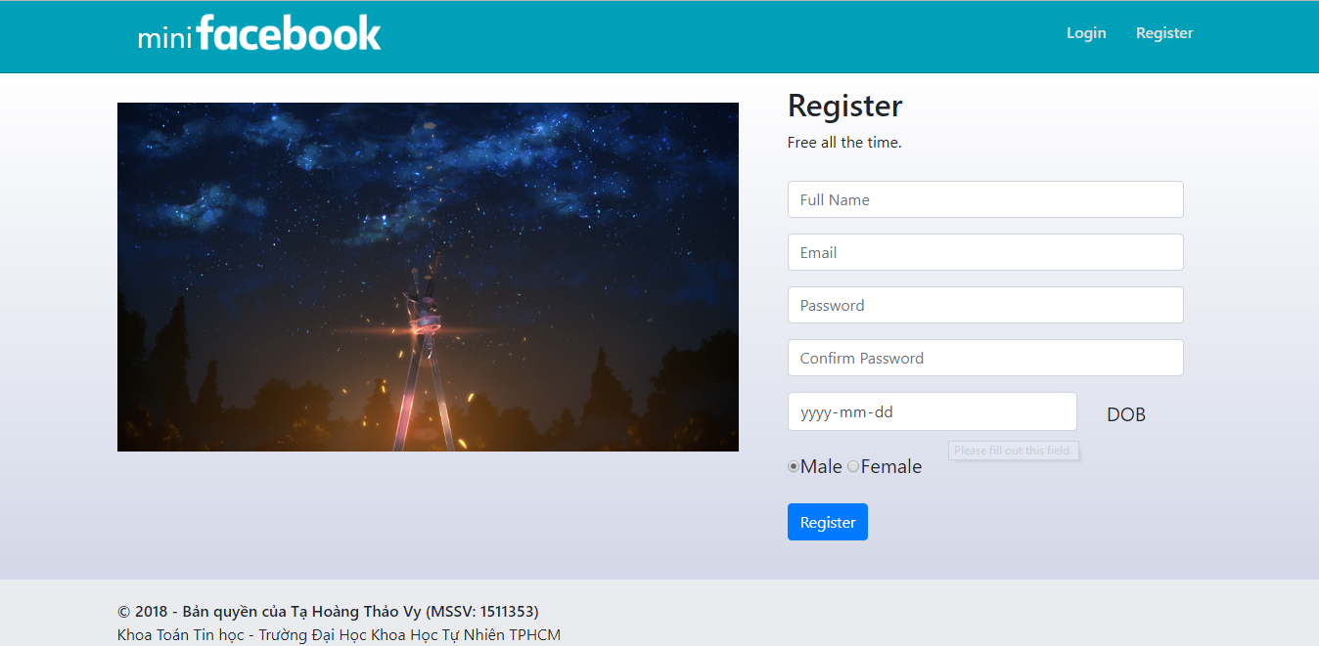

## Posts table:

This table save all the posts in miniFacebook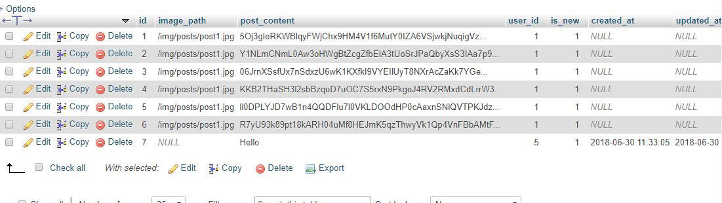

Fields explanation:

* “user_id” is stored the author of a post
* “image_path” to save image path if a post has an image (currently, a post can only upload ONE image)
* “post_content” to save the content of the post

## Comments table:

Every post has comments, so this table is to save comments of posts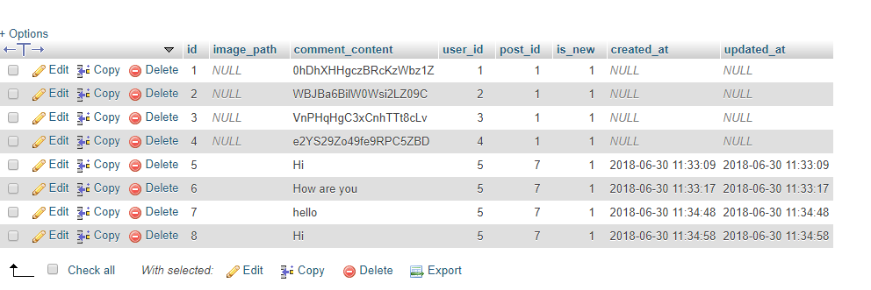

Fields Explanation:

* “image_path” this is not used at this time (currently, comment cannot upload image)
* “user_id” is then comment owner
* “post_id” is the post that they comment into

## Likes table:

This is an optional table, it is not in requirement, it stores likes of a post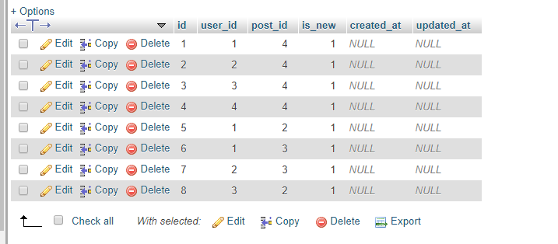

Fields explanation:

* “user_id” is the user who likes the post
* “post_id” is the post that use like
* “is_new” is using for notification

## Friends table:

This table show the relation ships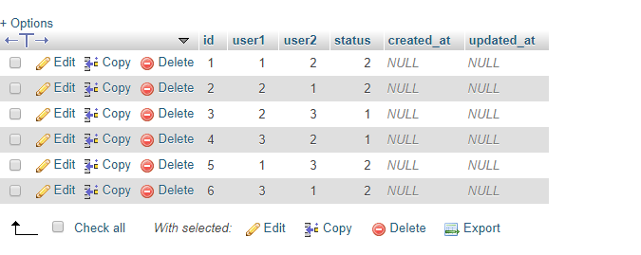

Fields explanation:

* “user2” is a friend of “user1”, that means “user1” is all so a friend of “user2”

Ex: user1 user2

1 2 (2 is a friend of 1)

2 1 (that means 1 is also a friend of 2)

This example shows how this table works

* What if there is only one side (Ex: there is only one row: 1 🡪 2)?
  + It means user 1 has just send friend request to user 2
  + If user 2 accept the request, there will be another side (2 🡪 1)
  + If user 2 not accept, the row: 1 🡪 2 will be deleted
* “status” tells they are friends or not

## Groups table:

This table save a group information: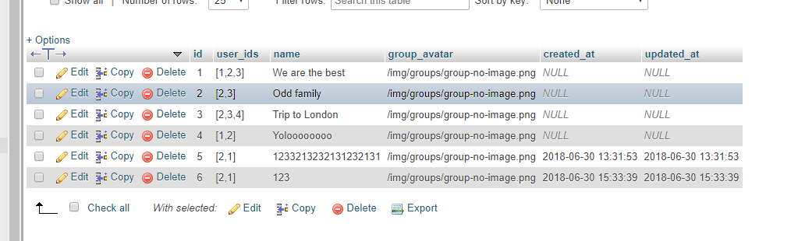

Fields explanation:

* “user_ids” is stored an array of user_ids in a group, this shows the members in a group
* “name” is a group name
* “group_avatar” is a path to the avatar of a groups, if not set, it defaults “group-no-iamge.png”

## Messages table:

This table stores all messages of chat groups or chat with friends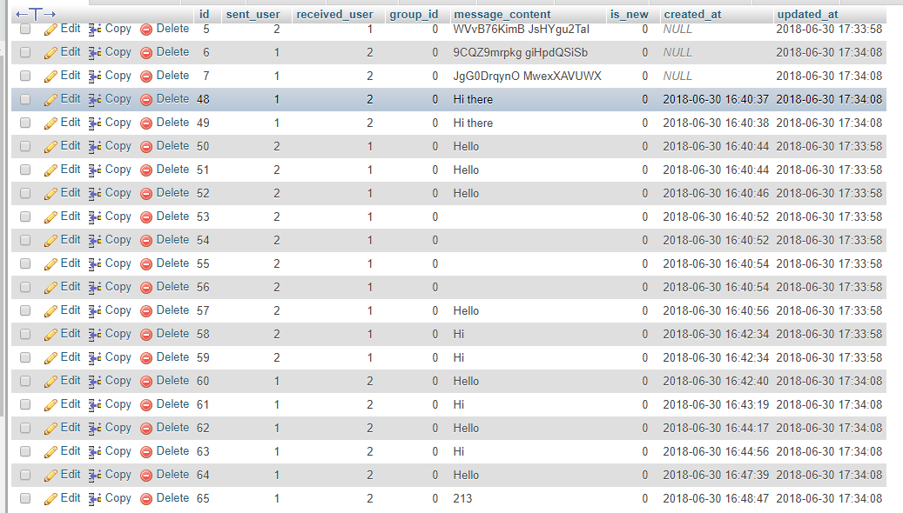

Fields explanation:

* “sent_user” is the user who sent the message
* “receiver_user” is the user who received the message. If > 0, this message is for friends, if == 0 this message is for groups
* “group_id” is the group which received the message. If > 0, this message is for group, if == 0 this message is for friends
* “messange_content” is the content of message
* “is_new” is for notification function in chat

# Frontend and work flows:

#### NOTICE: best use with Chrome

## Login/Register:

* Register form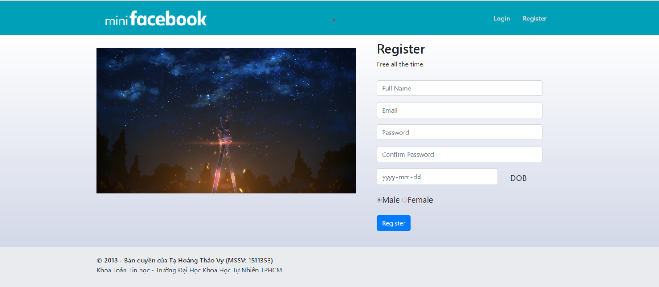
* Login form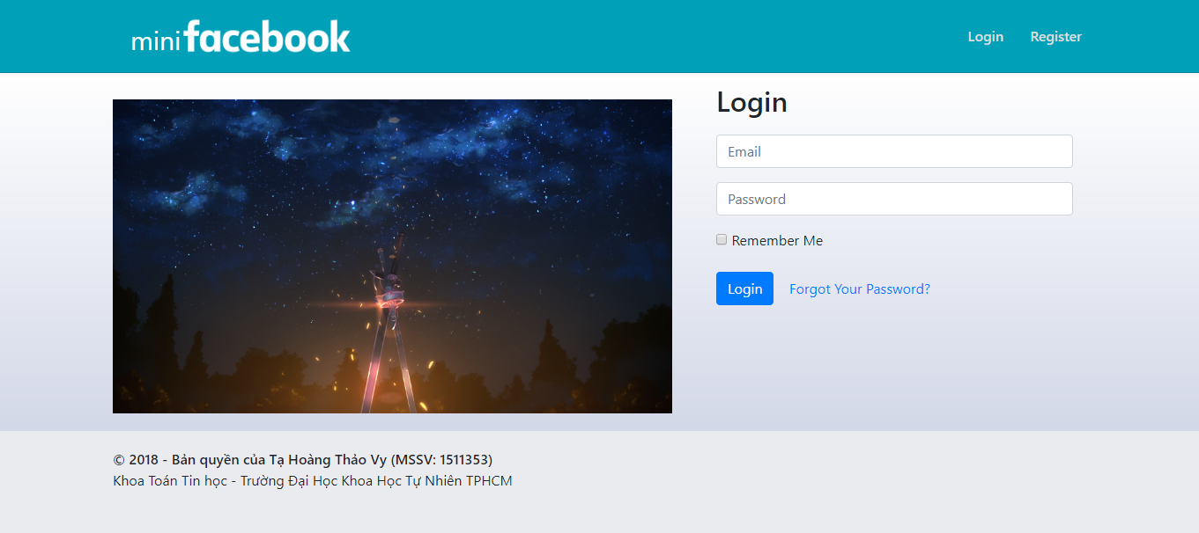
* Logout

## Home page

* Can only see friends’ posts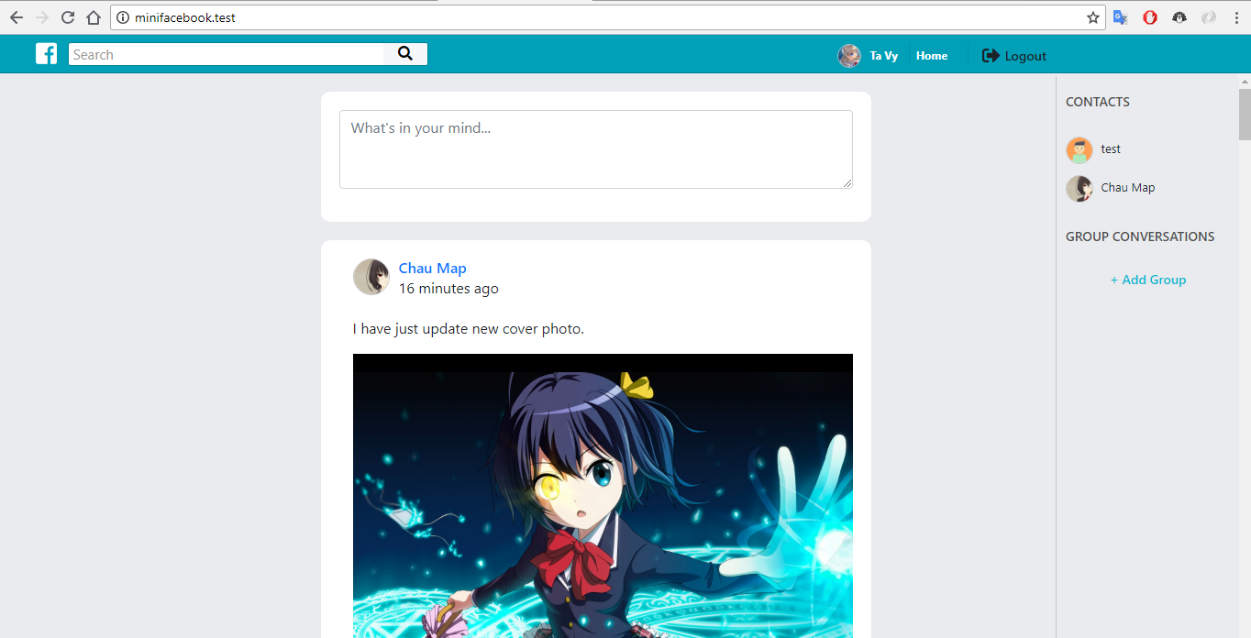

## Search user:

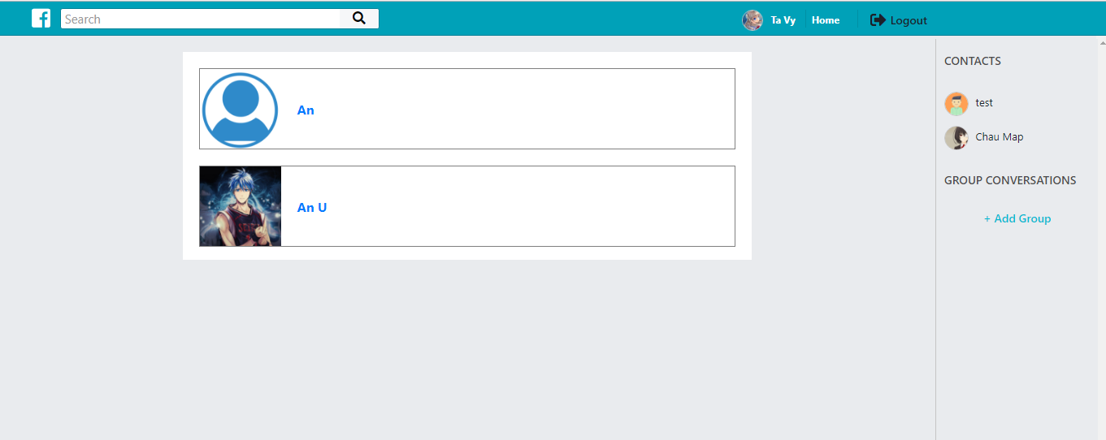

## View profile:

* Profile: View all this user post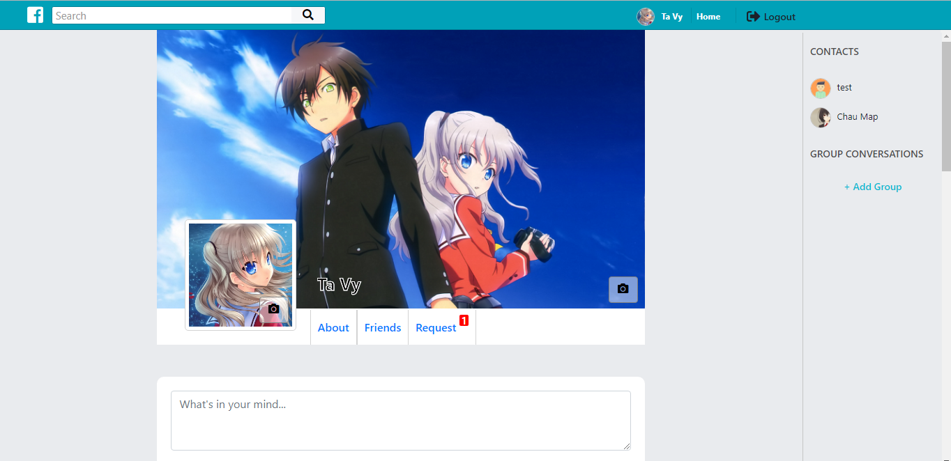
* View About:
* View friends: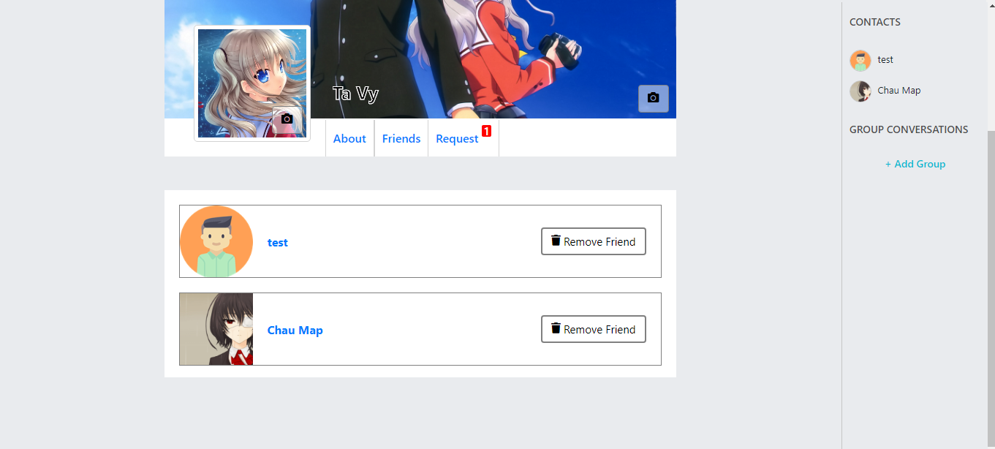
* View request: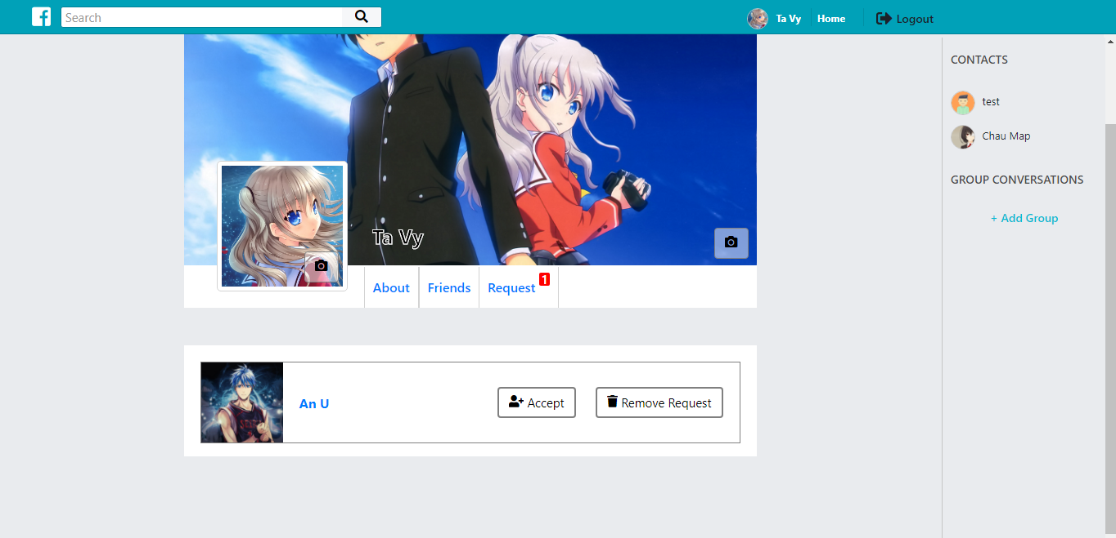
* Change Cover: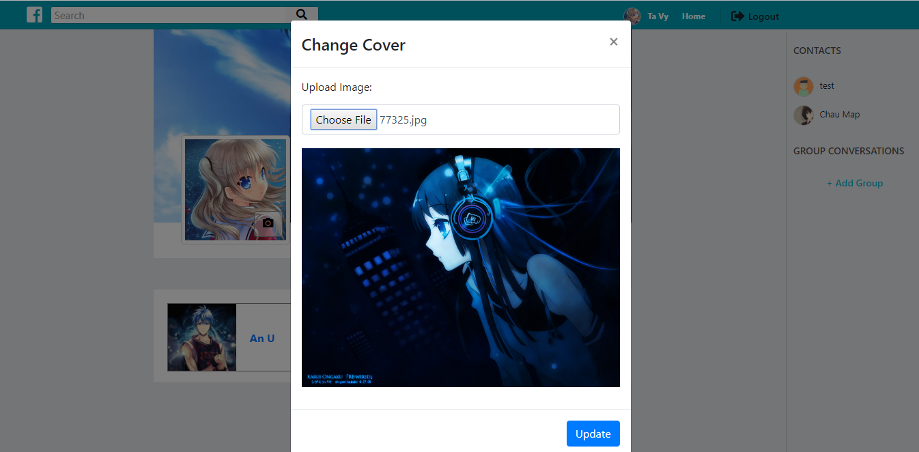
* Change avatar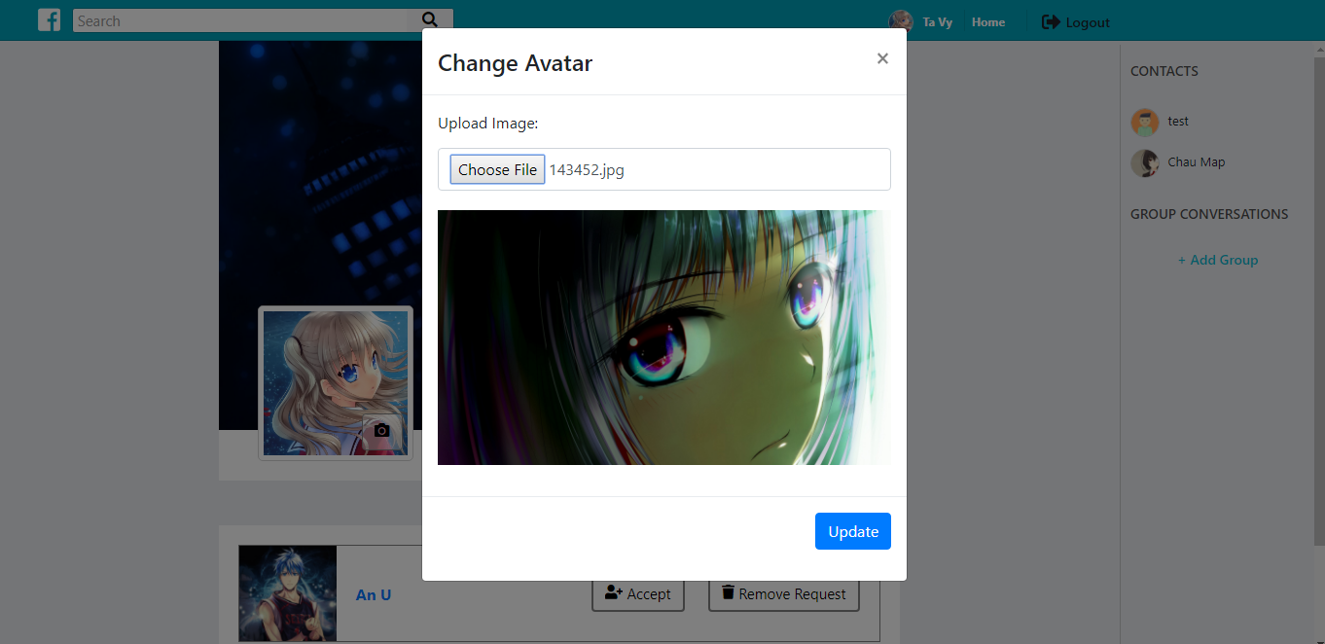

## Chat and message:

* New Group:

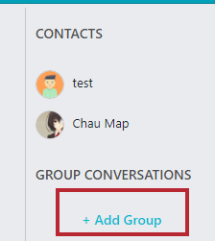

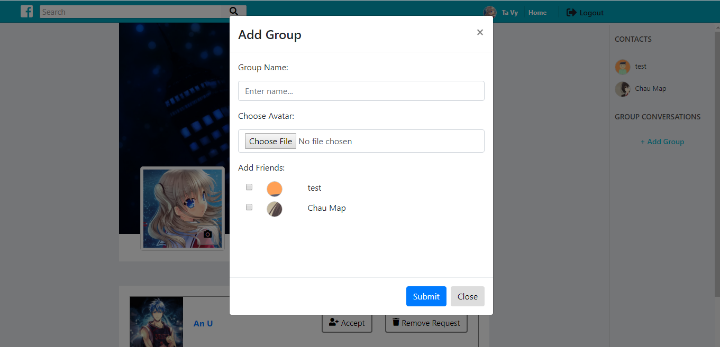

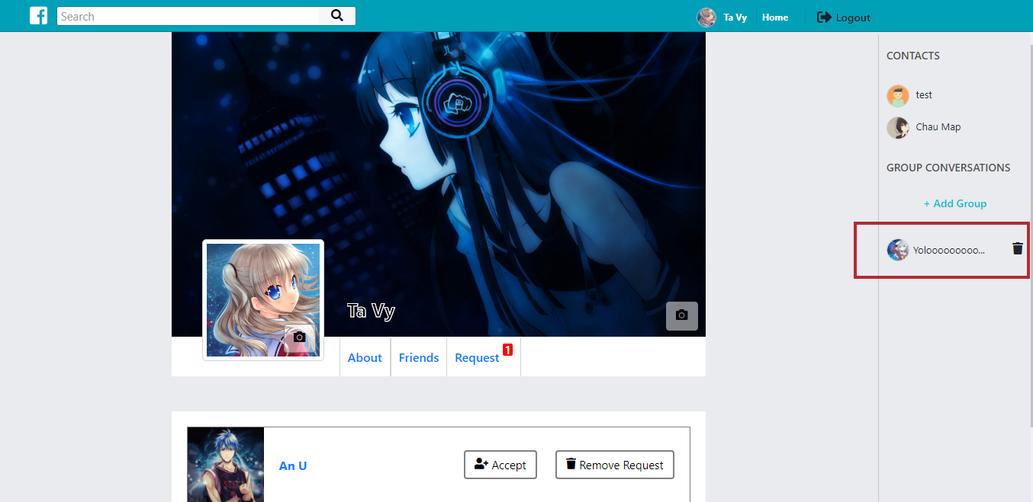

* Delete group: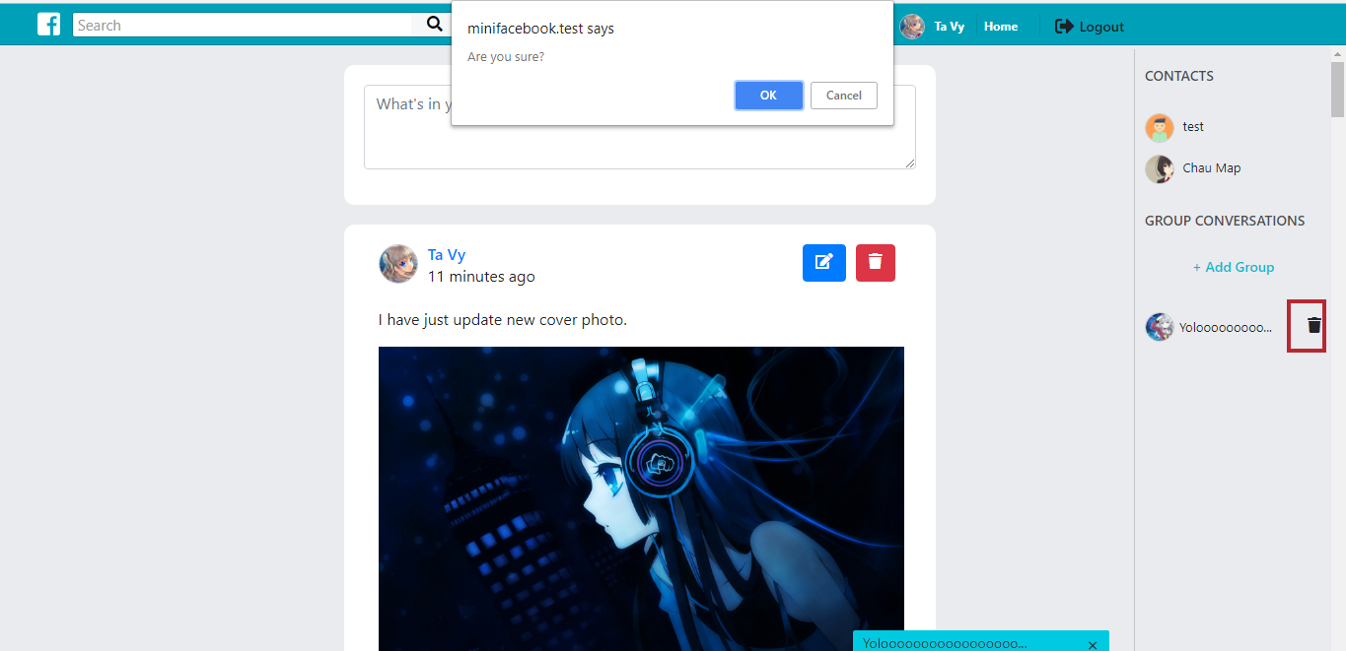
* Chat with group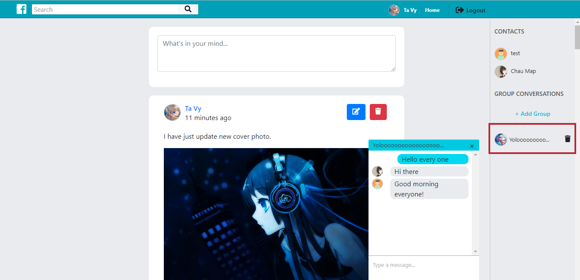
* Chat with friend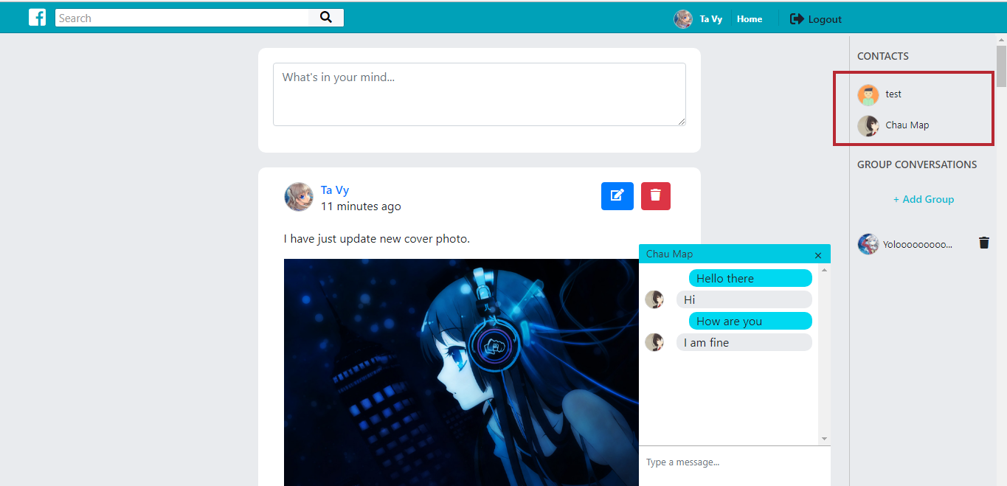

## Friends:

* Search users
* Then view user detail
* Then click add friend
* Wait for him/her to accept the request

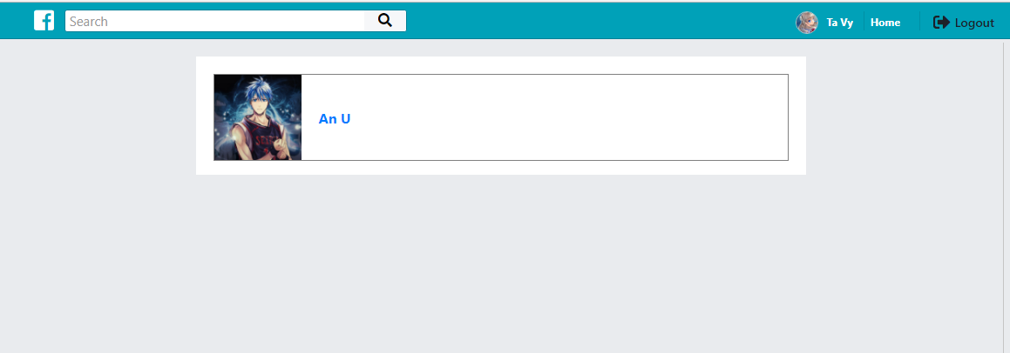

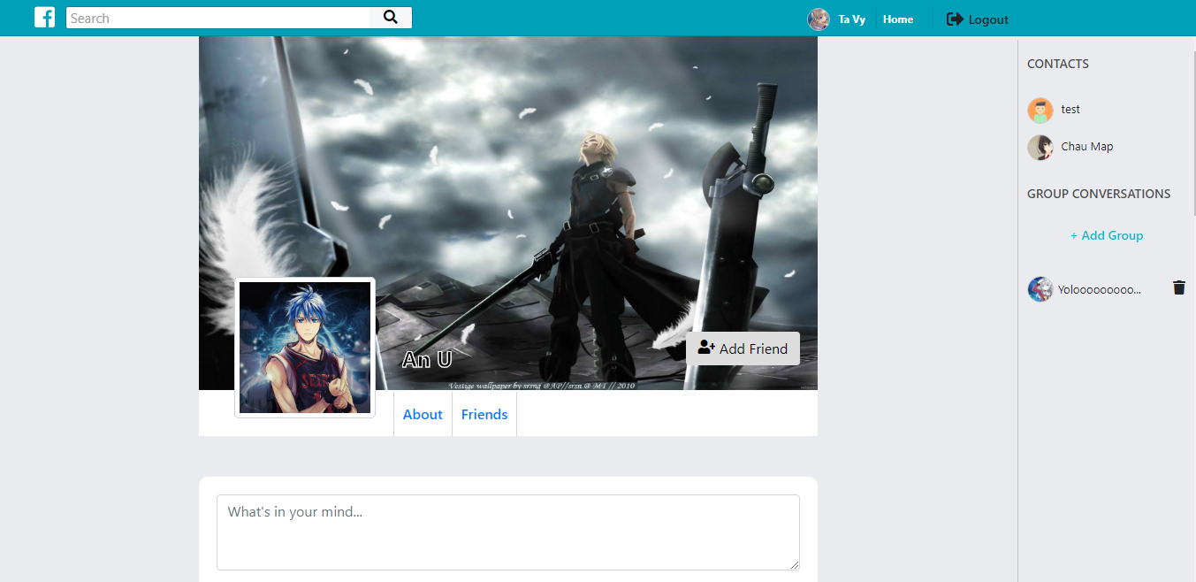

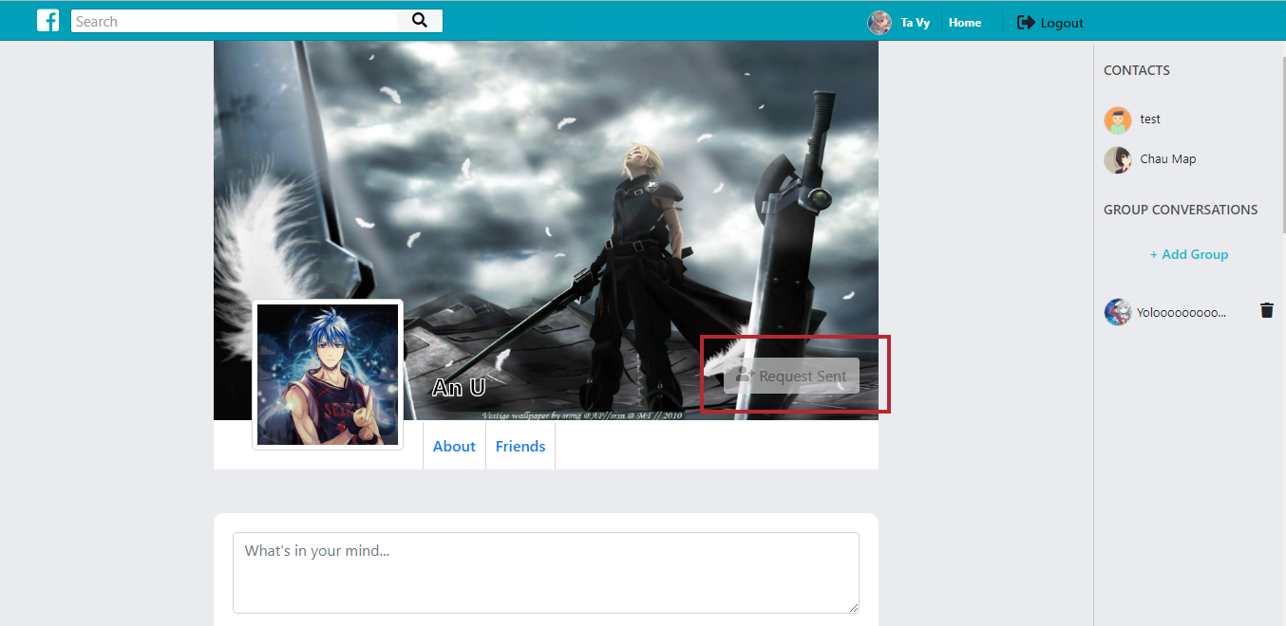

* Login as other user, and see request: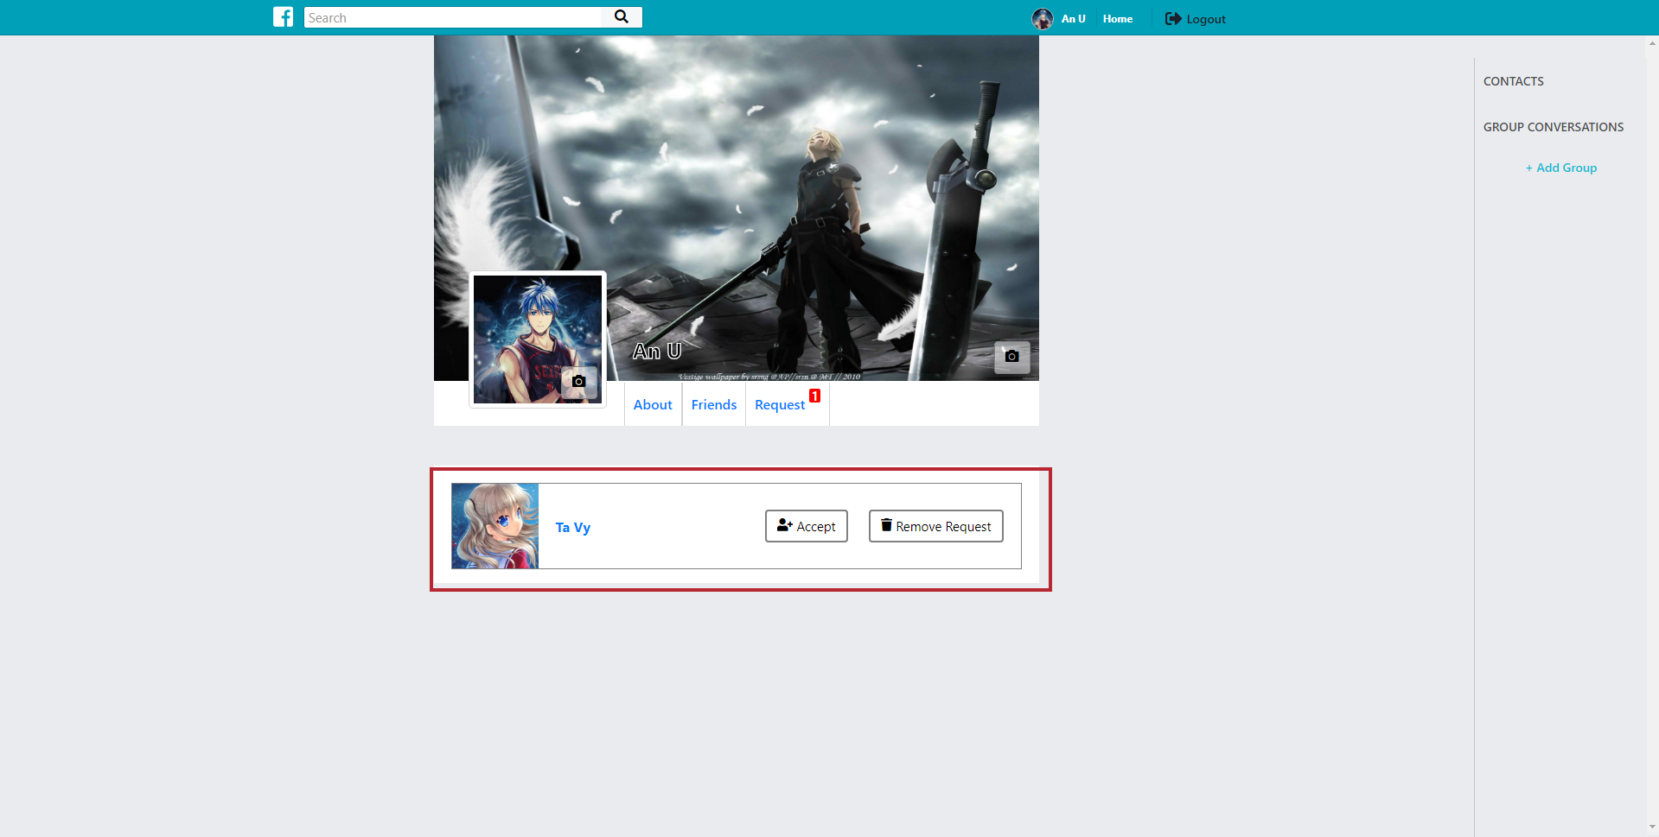

# Backend and functions:

## General explanation:

* Laravel is an MVC (Model View Controller) framework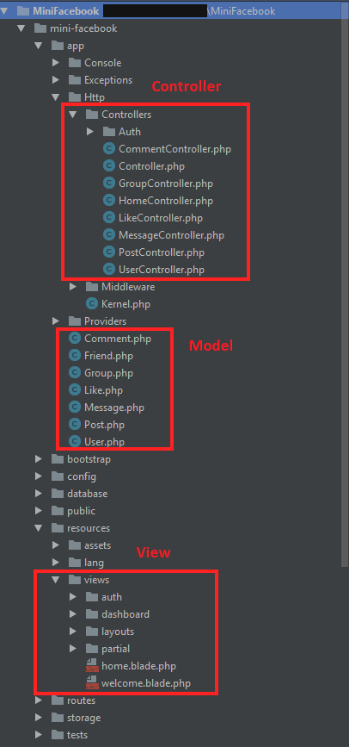

## Auth (login + register + logout):

These functions are supported by Laravel, I only run php artisan make:auth and it auto setup

All I need to do is added more fields in register page, and change the page layout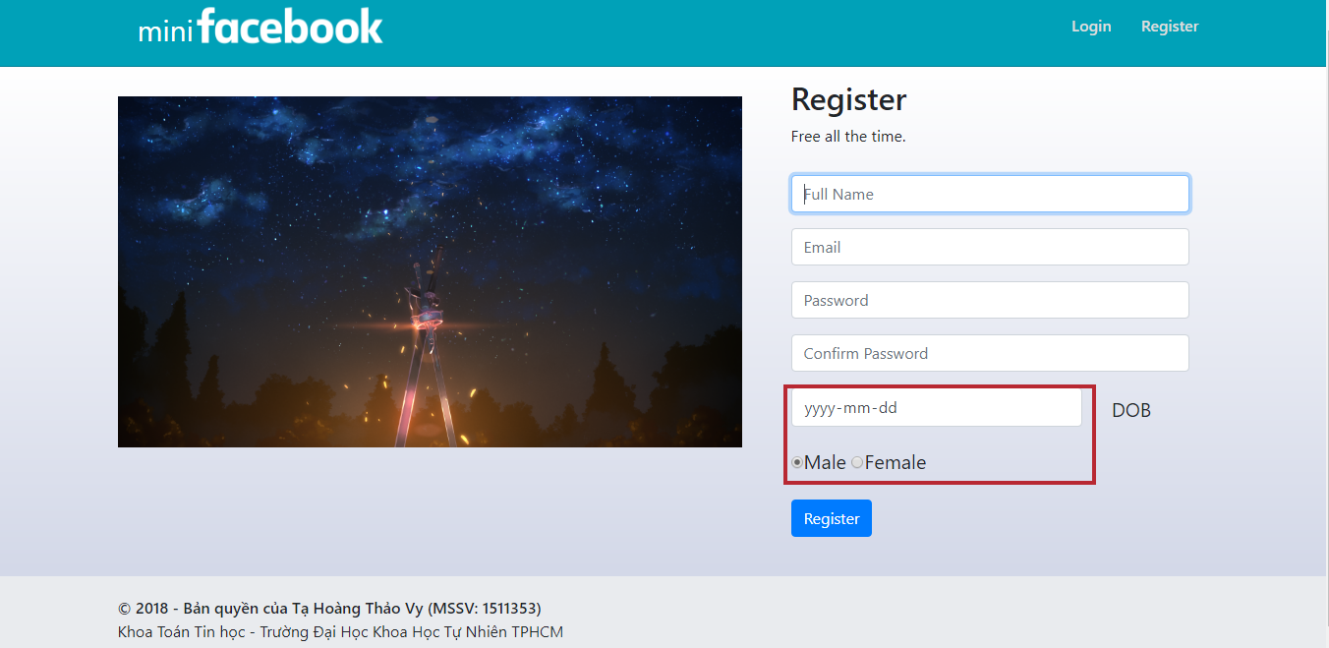

## Friend and group panel:

* Layout: 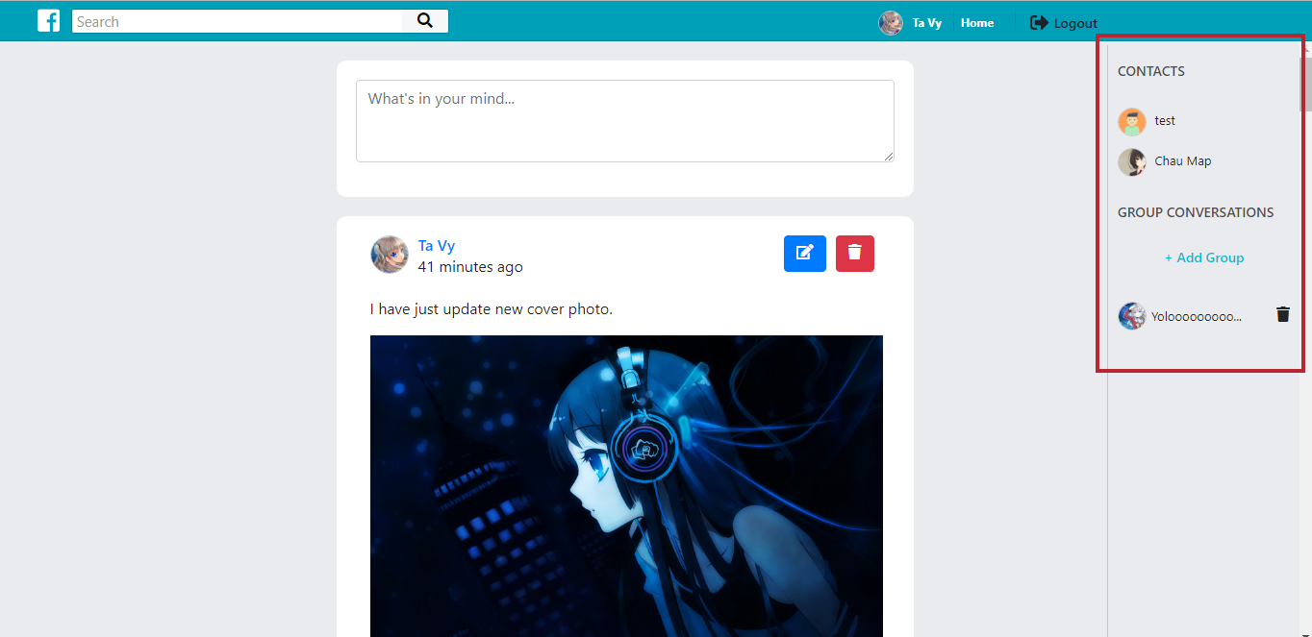
* It always appears at the right of the miniFacebook
* There is a function to get current user friends (in UserController.php)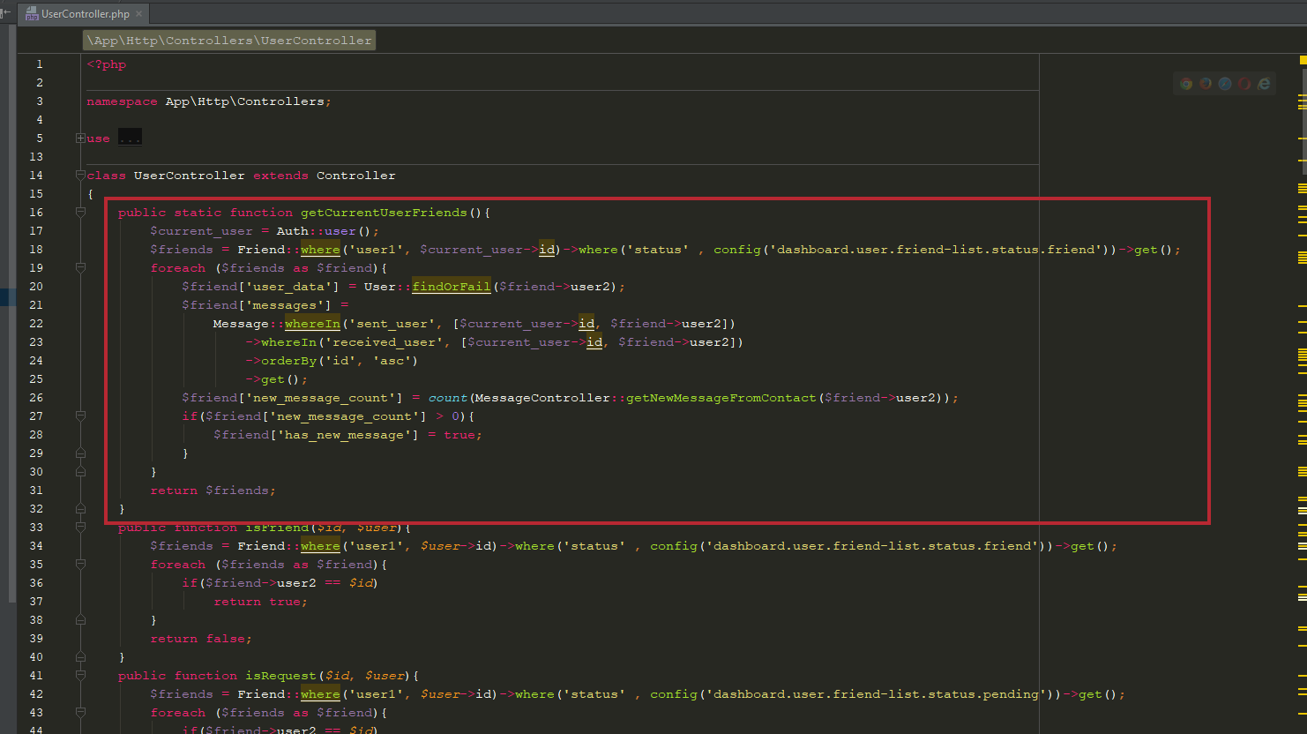
* There is also a function to get group list which is included current user (in GroupController.php) 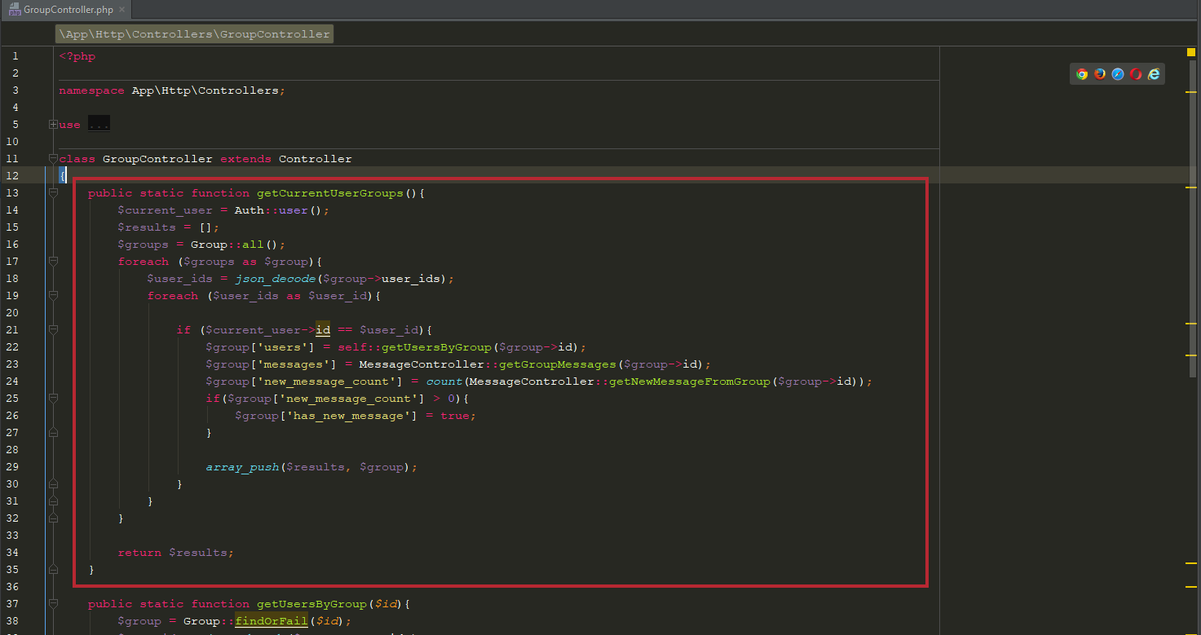
* For the add new group button: there is a function to do this too (in GroupController.php) 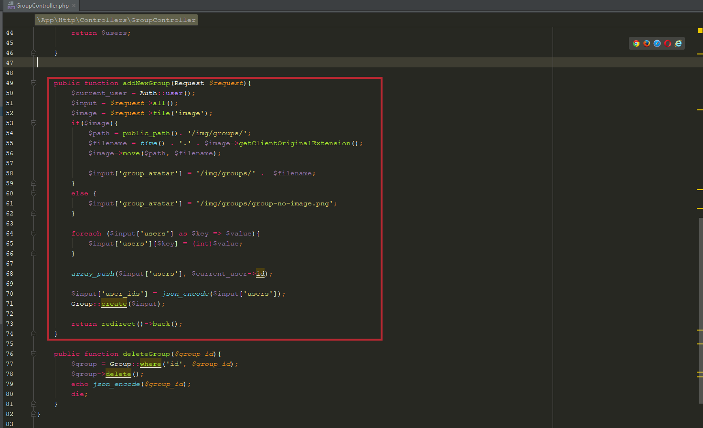
  + If the name of the group is too long (>12 letters) it will auto cut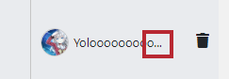
* Delete group (in GroupController.php): 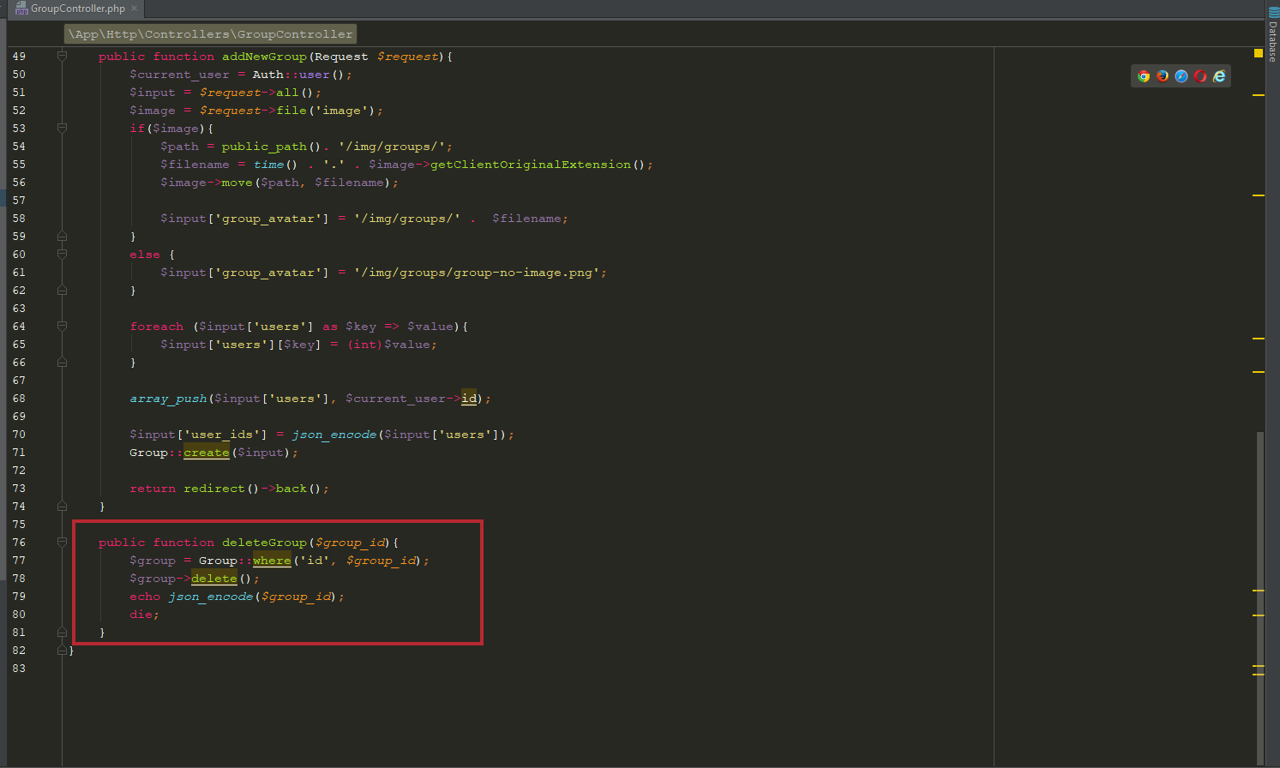
  + This function is called in an ajax request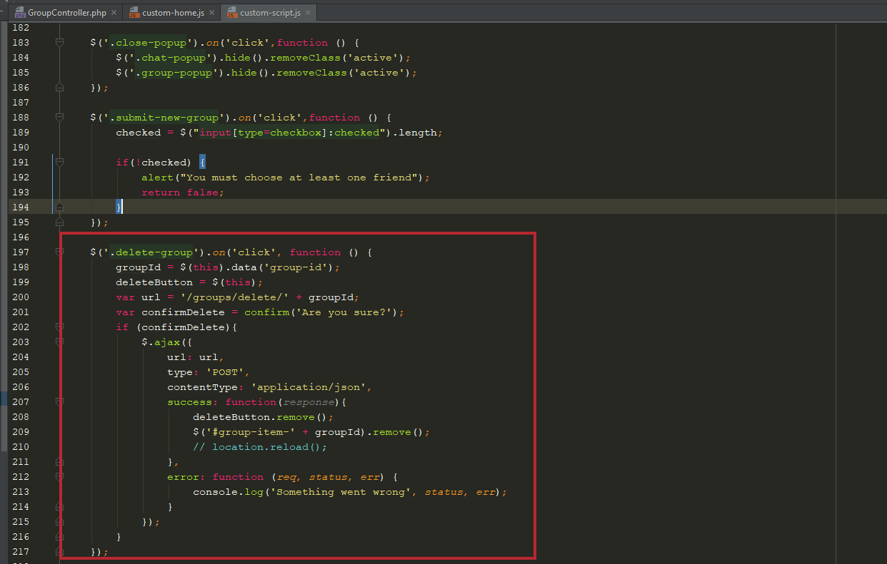

## Post:

* Layout: 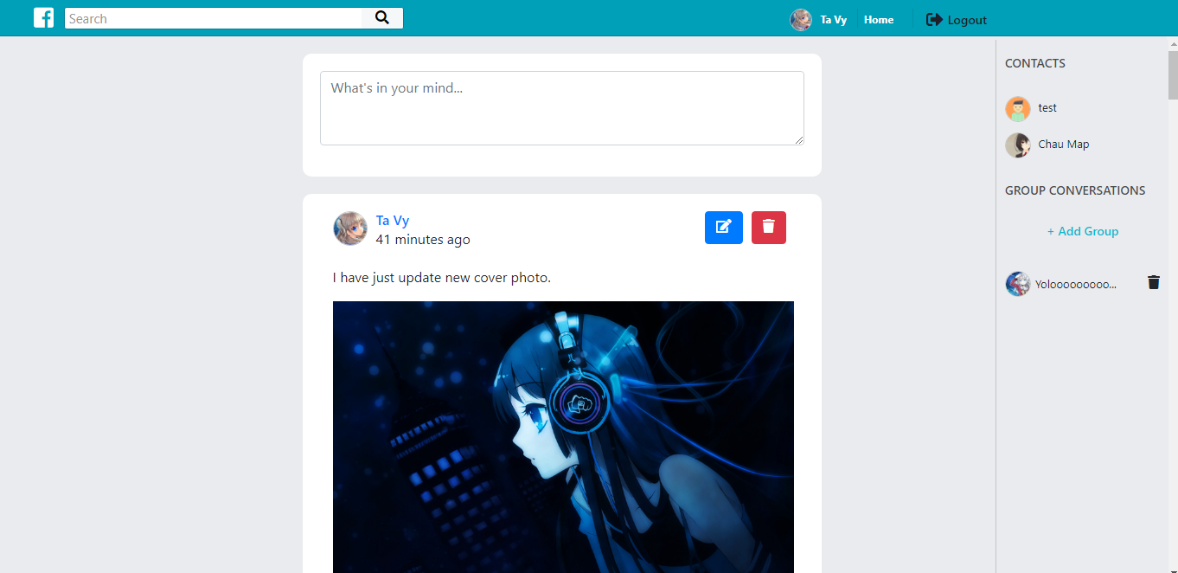
* Post: when focus on textarea, it will appear more fields

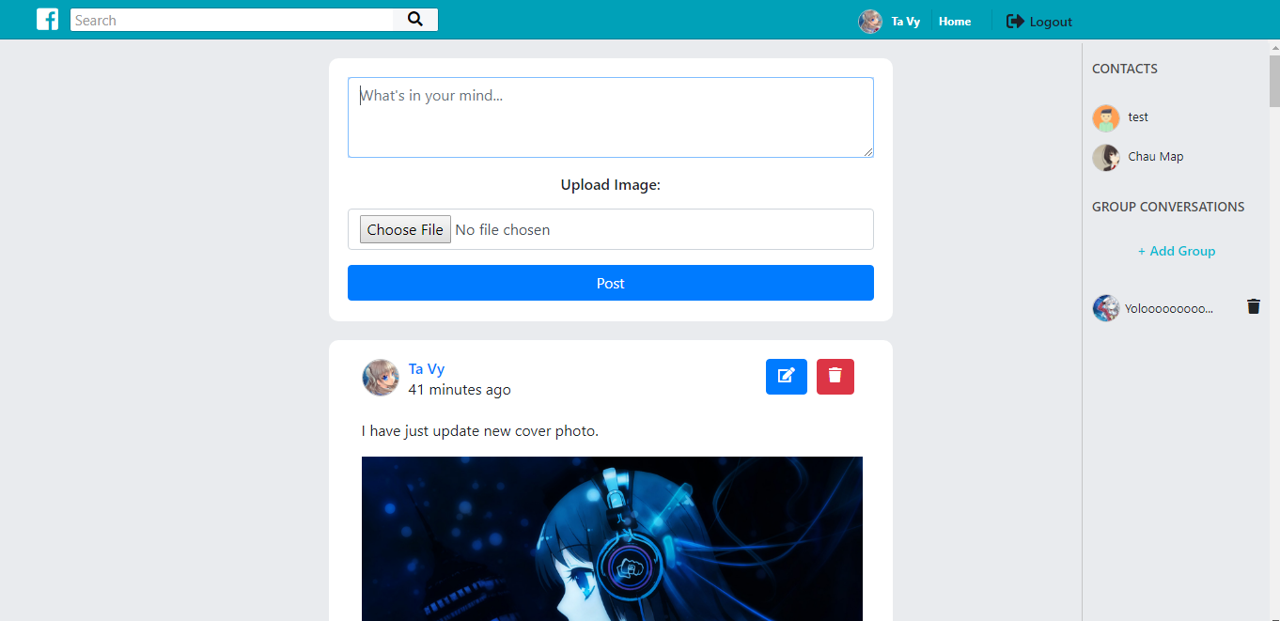

* After post: 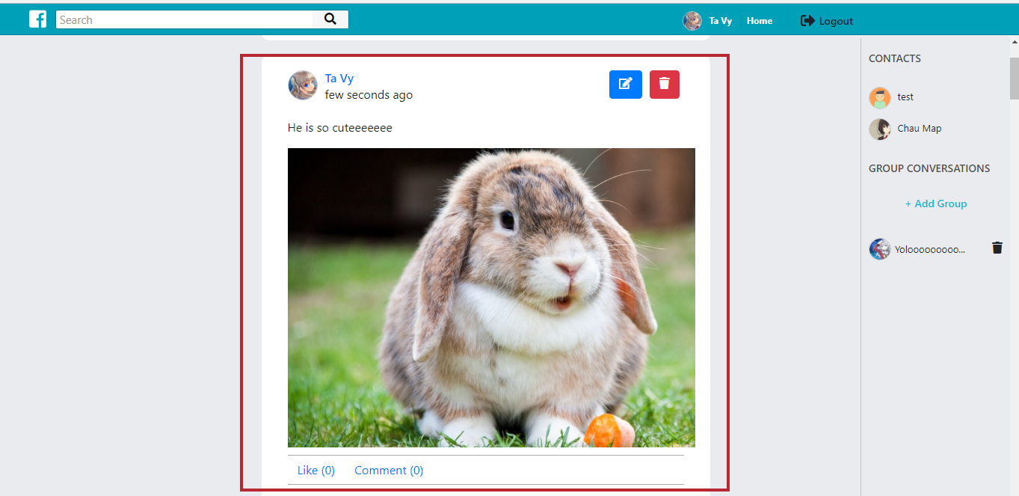
* Edit/delete post: only user who post the post can edit or delete it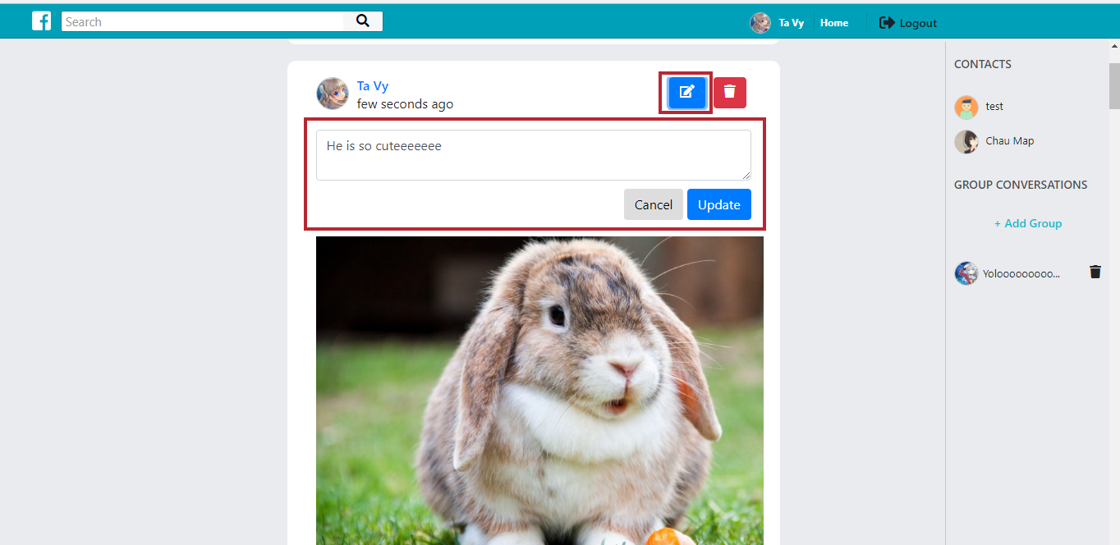
* All post functions are in PostController.php, this is the resource controller, it contains all methods of a model (list, create, edit and delete)

(more detail at: <https://laravel.com/docs/5.6/controllers#resource-controllers>)

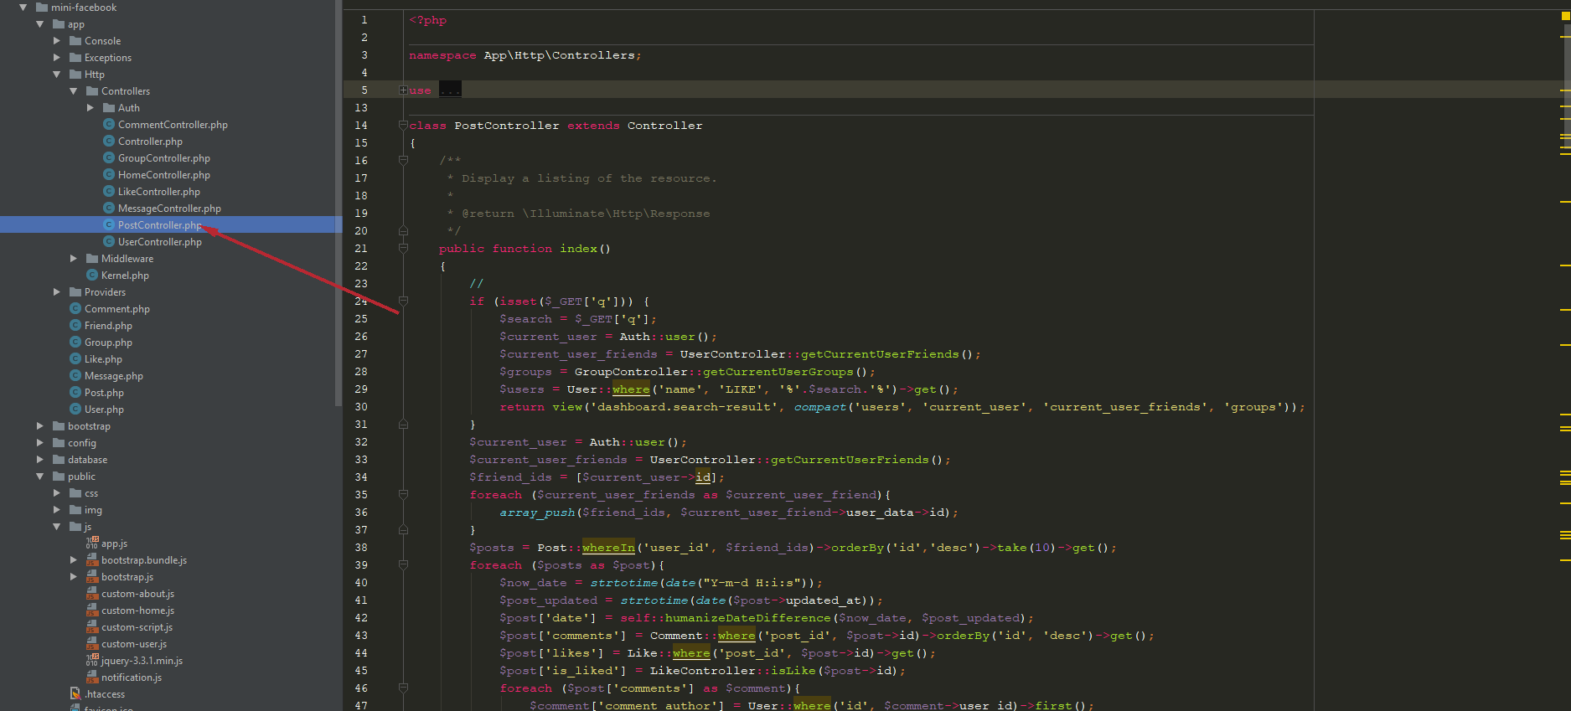

## Comments:

* When click comment under the post, it will show a comment container: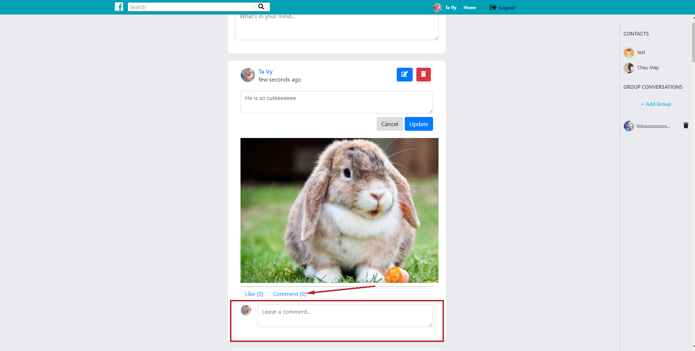
* Comment function also using ajax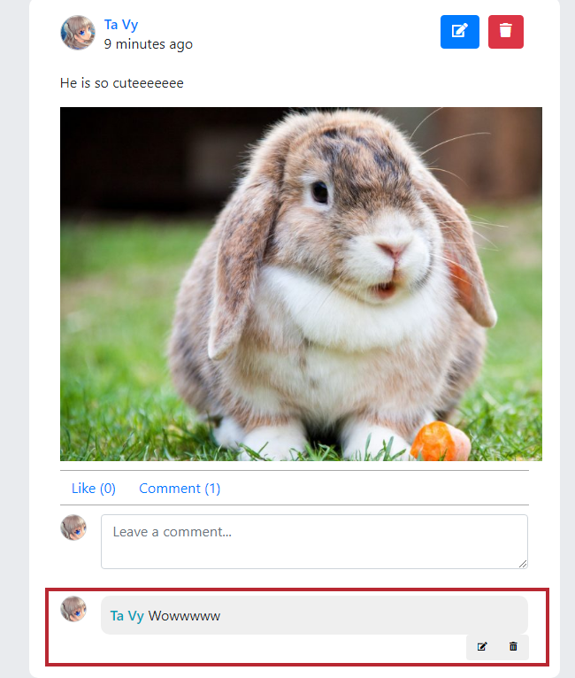
* Edit and delete comments: it works like functions in post, only author of the comment can edit or delete the comment.
* Functions are all stored in CommentController.php

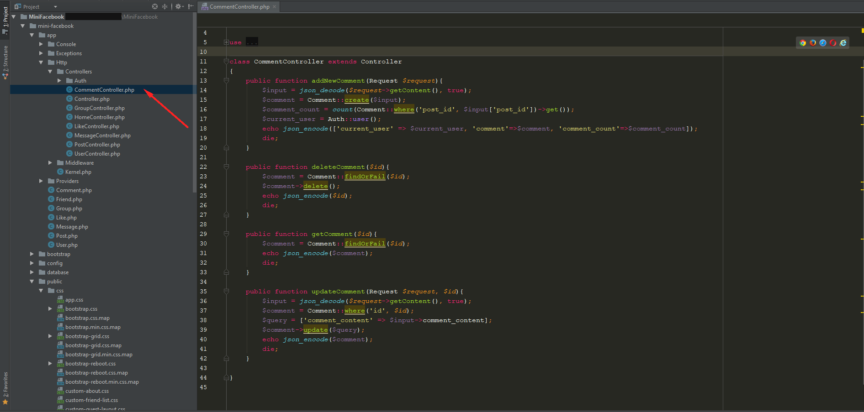

* Ajax functions for comment are in “/public/js/custom-user.js” 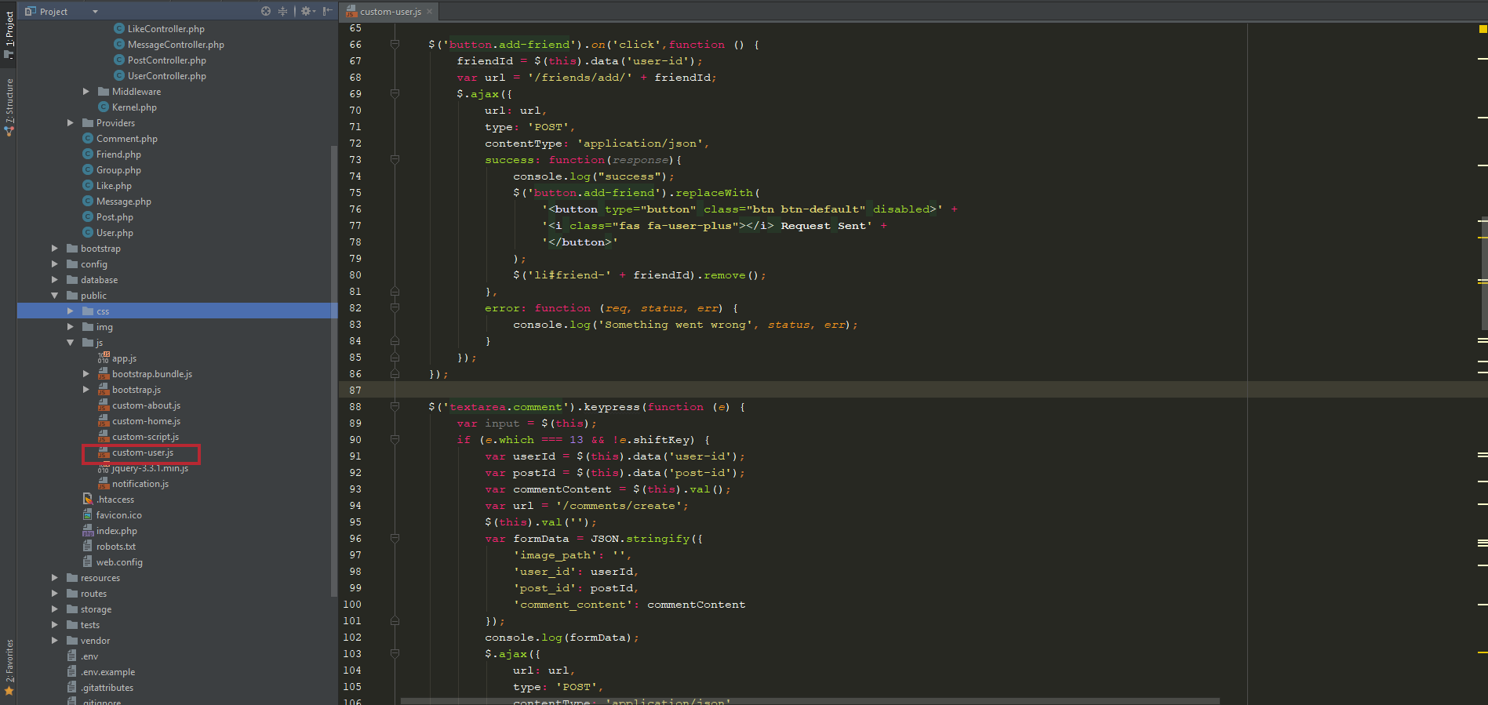

## Likes:

* It will all a row in database when a user click likes
* And remove when user unlike
* Functions are stored in LikeController.php
* Ajax functions are stored in “/public/js/custom-script.js”

## Friends and requests:

* A friend relation ship is stored in database by 2 rows 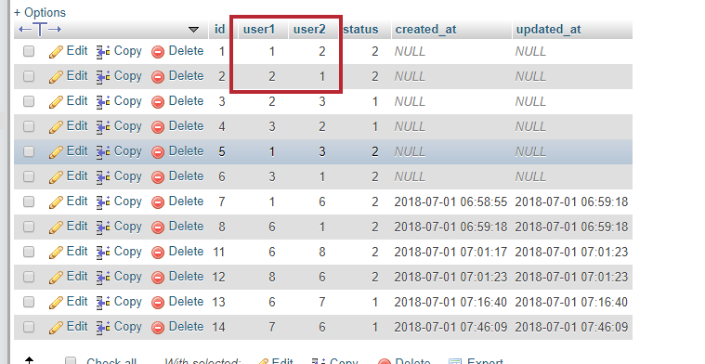
  + This means user_id = 1 has a friend relationship with user_id = 2
* When user1 send request to user2, there is only ONE row 1 🡪 2
* If user2 accept the request, it will create a new row 2 🡪 1, and change “status” to 2
* Else, it will delete the row 1 🡪 2
* Request is having notification: 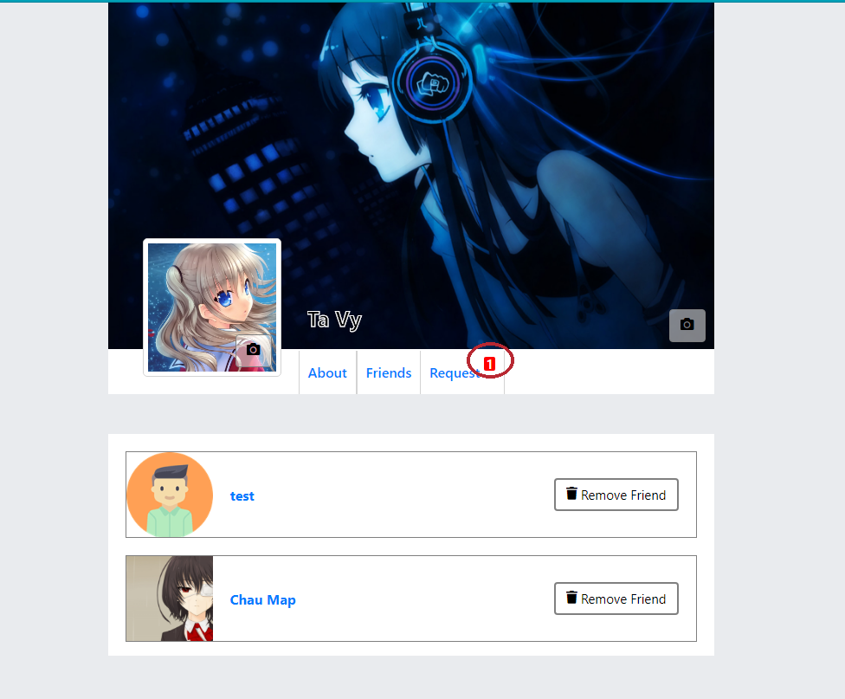
* All functions are stored in UserController.php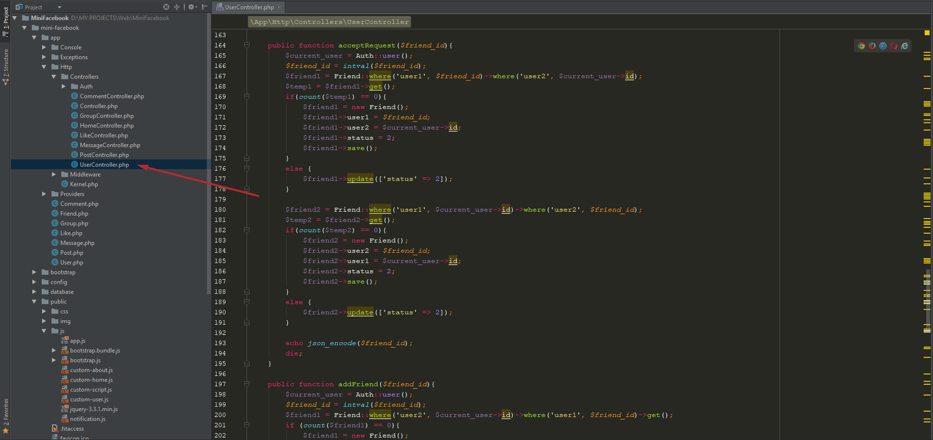
* Ajax functions are in “public/js/custom-user.js” 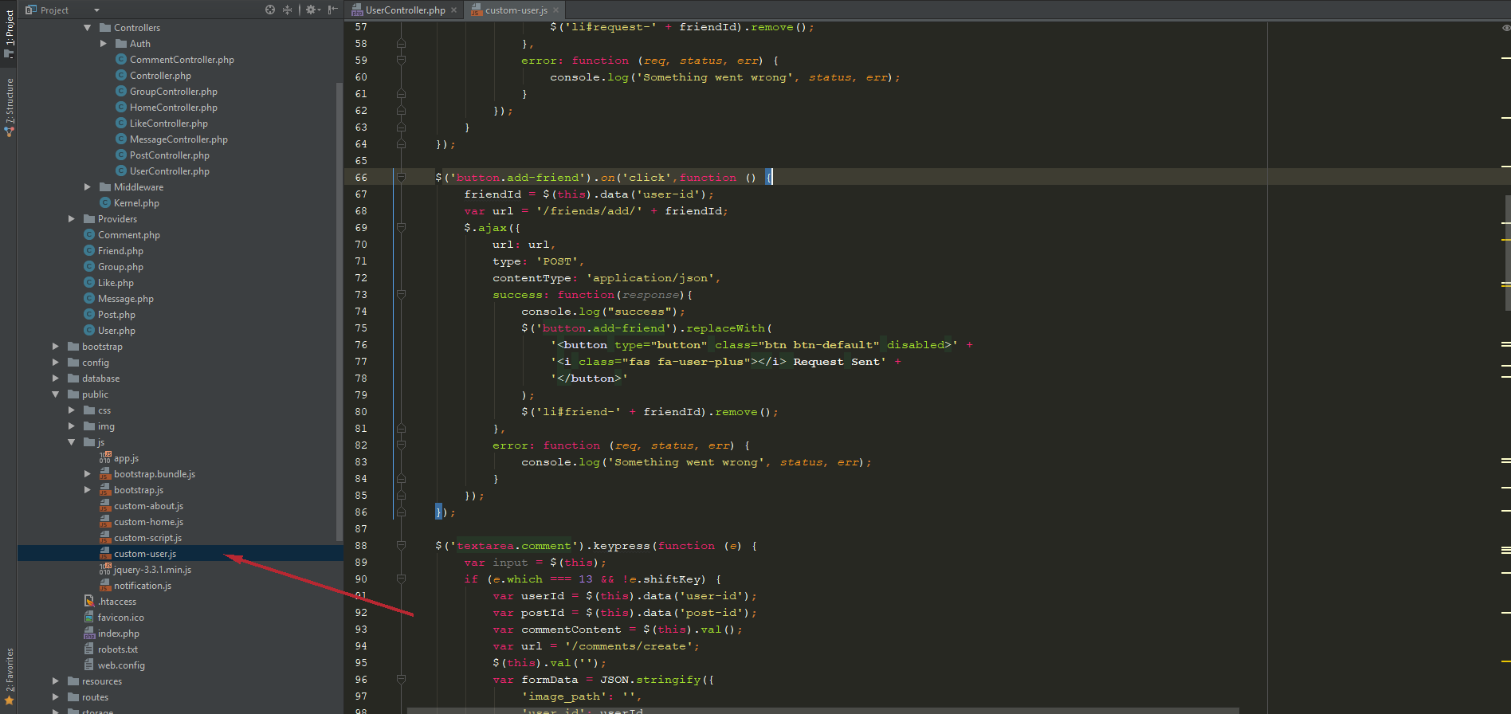

## Chat messages:

* Chatting with friend is similar as chatting with group
* This also using ajax function to update new chat
* All functions are in MessageController.php
* All ajax functions are in “/public/js/custom-script.js”
* This has an interval function to get message from database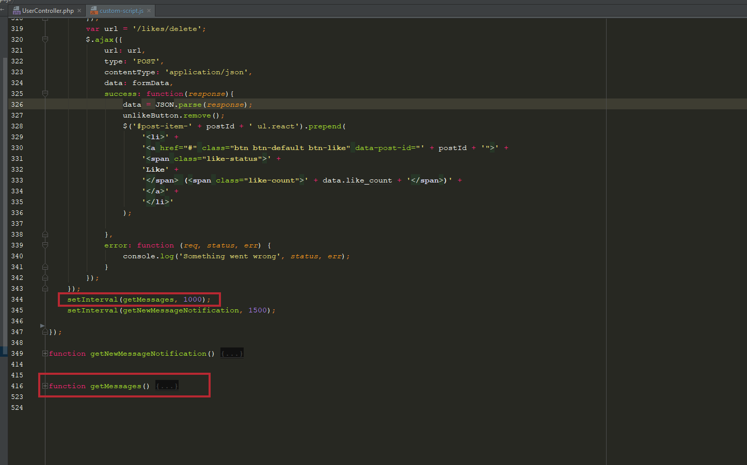
  + This means, every 1000milisecond (1s) it will call a function and update chatbox. So, user do not need to reload page after every messages!!!
* Messages also have notification, and interval function for getting message notification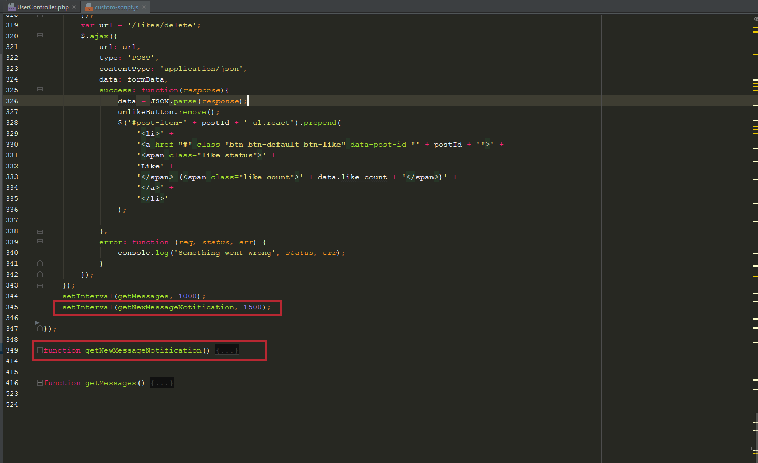
* It will update red number on the right of the contact items (without reload the page)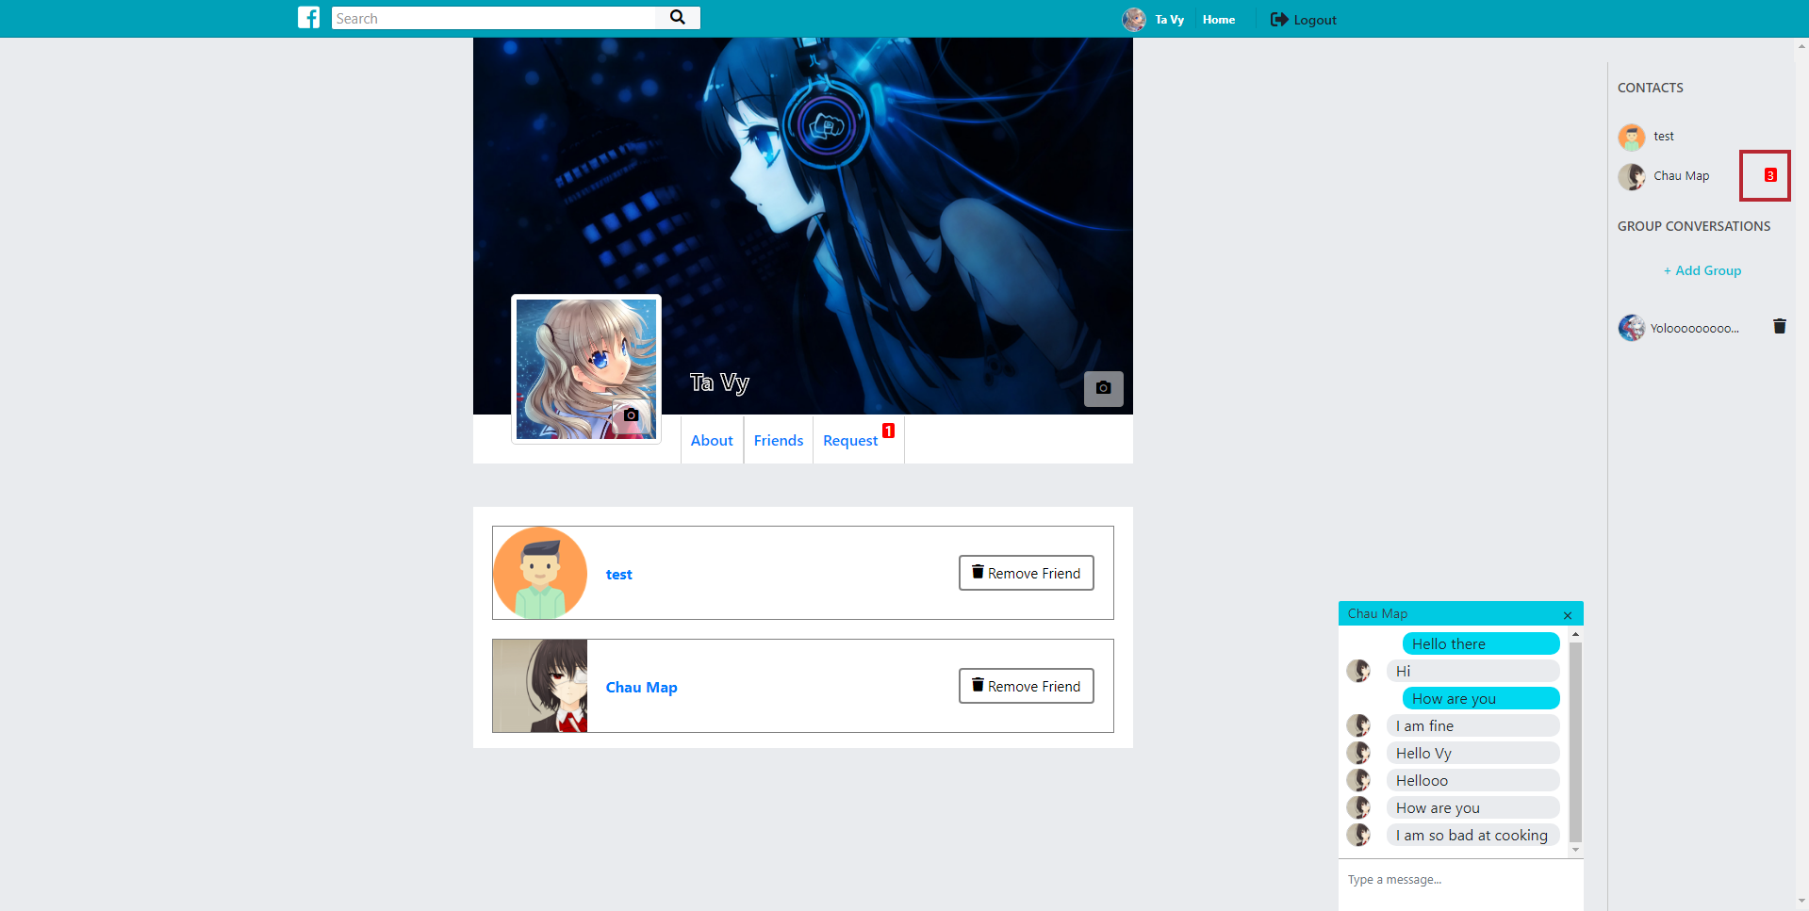

## User profile:

* Avatar and Cover: User can easily change the avatar and cover by clicking on the camera buttons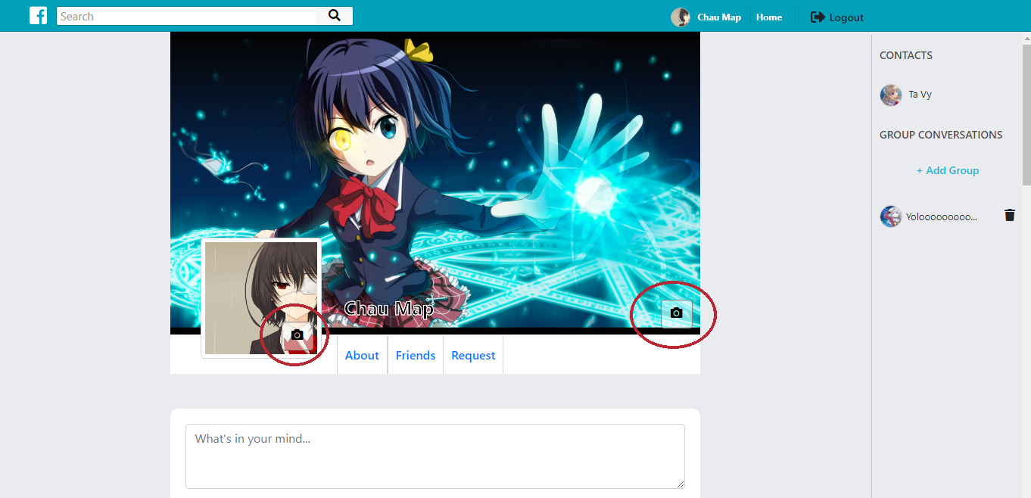
* These functions are in UserController.php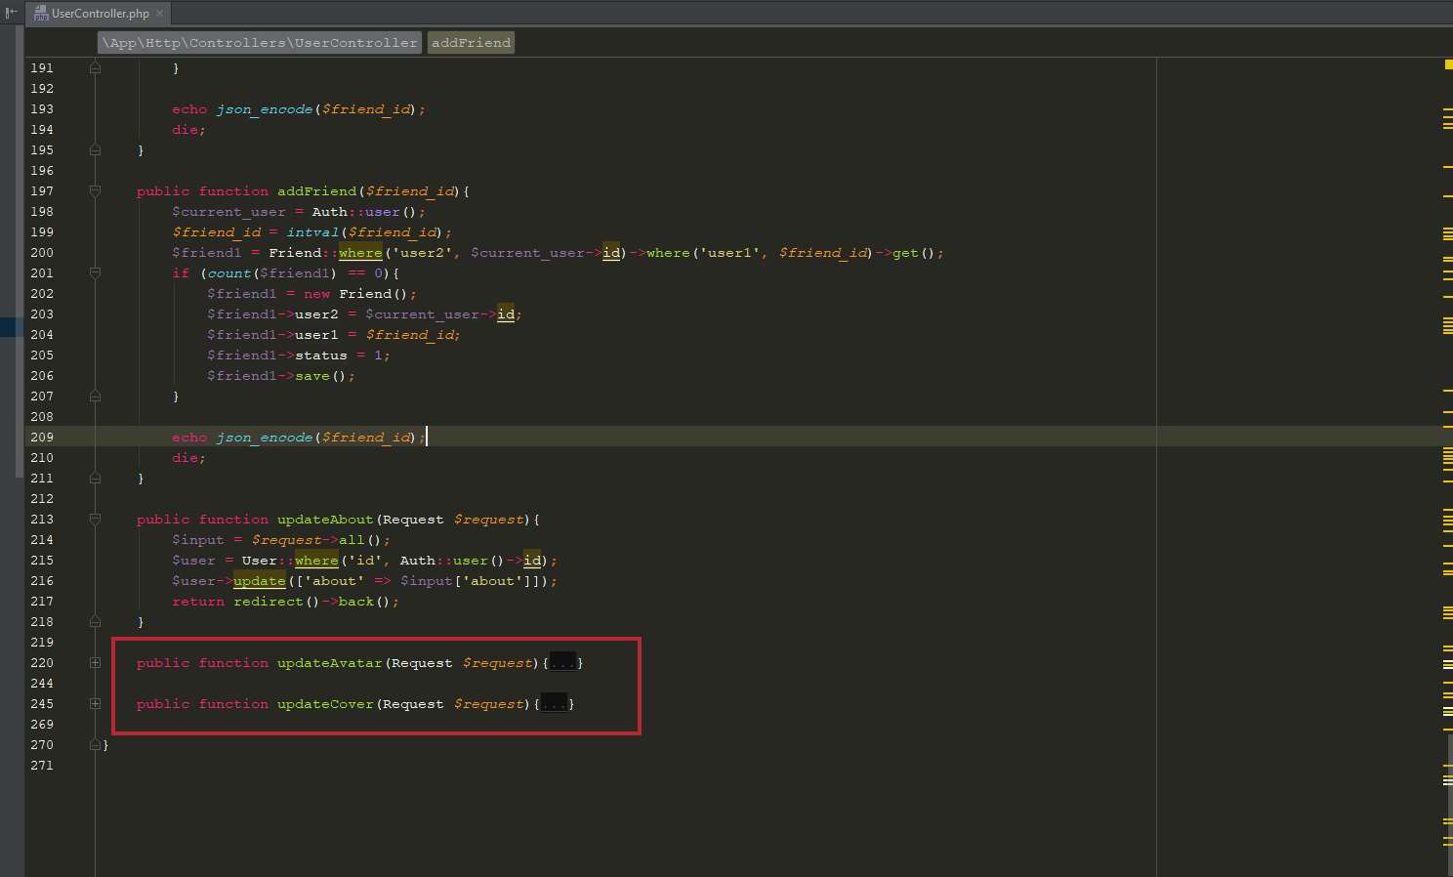

END.